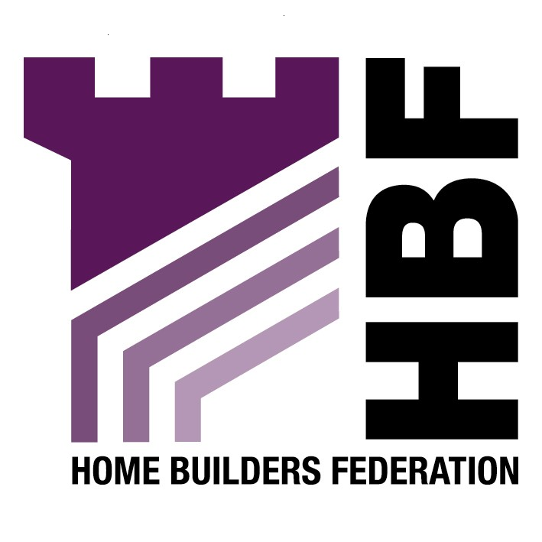

Emailed to ldf@leeds.gov.uk
Leeds City Council
The Leonardo Building
2 Rossington Street
Leeds
LS2 8HD

05 September 2007

Dear Sir or Madam

Sustainable Design and Construction Draft SPD

Thank you for giving the Home Builders Federation (HBF) the opportunity to comment on the above document. The HBF have considered the proposed document and have made the following observations:

General

Any matters of importance to development costs need to be clearly set out in a Development Plan Document (DPD), rather than being delegated down to a SPD. Given that they could potentially have a very significant impact on development viability, they must instead be dealt with in DPD’s and subject to the appropriate public scrutiny bestowed upon these.

Planning and Climate Change

Planning and Climate Change (December 2006) states in paragraphs 27-39 that in determining planning applications LPA’s should ensure they are consistent with PPS1 and avoid placing inconsistent requirements on applicants. Paragraph 30 says that with regard to the environmental performance of new development, planning authorities should “engage constructively and imaginatively with developers to encourage the delivery of sustainable buildings. They should be supportive of innovation”.

Paragraph 31 of the draft document states that “LPA’s should not need to devise their own standards for the environmental performance of individual buildings as these are set out nationally through the Building Regulations”.

The document says that LPA’s when addressing energy supply should:

Assess their area’s potential for accommodating renewable and low carbon technologies. Working closely with the industry and other experts, LPA’s should:

- Make the most of opportunities to utilise existing decentralised energy generation;

- Allocate sites for renewable and low carbon energy sources;

- Look favourably on proposals for renewable energy; and

- Ensure a significant proportion of the energy supply of substantial new development is gained on-site and/or from de-centralised, renewable/low carbon sources.

In undertaking this, LPA’s are told to:

- Have regard to the overall costs of bringing sites to the market;

- Ensure their approach is consistent with the need to deliver sufficient housing sites required by PPS3;

- Make realistic assumptions on the availability of technologies and thresholds for their viable delivery;

- Consider the contribution already made through the energy performance requirements of the building regulations;

- Recognise that off site generation and supply may be more efficient;

- Consider the potential for on-site supplies to meet wider local needs; and

- In proposing increases in the proportion of energy gained from renewable sources such targets should be set out in a clear and realistic timeline to allow developers to adjust successfully.

It is far from evident, that the Council has taken the above matters on board.

3. Overall Standard

The HBF considers that the requirements for new housing to meet Levels 4-6 of the Code for Sustainable Homes to be premature. The development industry has signed up to the target of all new homes being built to an agreed zero carbon standard by 2016. In order to achieve this, the industry should be able to rely on a clear national framework and timetable for the necessary changes in building regulations. This approach will enable industry to work with greater confidence and efficiency to find the best means of delivering homes to the new standard in the volumes needed. The Council has to accept that at the moment the Code is still voluntary, and imposing unrealistic standards is very unhelpful.

It has been acknowledged in various studies recently that it takes a long time for a developer to obtain planning permission and that, if anything, that time is getting longer rather than shorter. For large development we are looking at many years and even relatively modest developments can take 18-24 months from initial pre-application discussions with an authority to the issuing of final consent. Given that timescale and the nature of the negotiations and financial commitments developers have with landowners, the rules simply cannot change overnight. The achievement of Code Level 3 is estimated to add between £3,000 and £5,000 to the cost of a dwelling. And that is not the additional cost over current minimum building regulations standards. That is the cost over achieving EcoHomes Very Good standard. You can add another £2,000 per unit to account for the difference between current building regs and EcoHomes very good. So that is an additional cost burden of £5,000 to £7,000 per dwelling which has not been factored into any land price calculation or negotiation.

The only possible outcome of imposing such a requirement can be to delay or stymie development at a time when under-supply of housing and the impacts of that on affordability and quality of life etc in the region, is endemic in this part of the world. Developers will have to either go back to landowners and re-negotiate financial contracts (which landowners may not be willing to do) which will, at best, add further delay. At worst it will result in sites being tipped over the balance in terms of viability. It is not just an issue of £5,000 to £7,000 per unit. It is the plethora of other s106 obligations local authorities load on to new development (some appropriate, many not), not least of which is the obligation to provide high levels of affordable housing, which add to the burden. Something has to give and if this new Code 3 requirement is to be brought forward immediately then authorities will have to compromise on other s106 financial requirements or sites will not be developed. That is absolutely the opposite of what Government planning policy is setting out to achieve.

4. Energy Efficiency/ Carbon Emissions

The HBF objects to the inclusion of separate targets for renewable energy in this document: “10% on site renewable energy provision up to 2010, 15% up to 2015 and 20% up to 2020.” The HBF believes that any requirement for renewable energy provision upon new development should be delivered through the higher stages of the Code for Sustainable Homes. As this is a framework and timescale to which the industry is committed to delivering. The HBF consider that the application of locally based energy performance standards would be unhelpful in facilitating the broader delivery of higher energy performance and consumption standards from new housing.

If the Council feels that it has justification for requiring higher standards for energy efficiency than the current Building Regulations, it should have a target for an overall reduction in carbon emissions, rather than requiring a separate target for renewables, which are at this stage inefficient, expensive and short lived.

13. Accessibility
Lifetime homes

With regard to the requirement that a proportion of housing development should be “lifetime homes” there are a number of means of providing access and flexibility without specifically requiring lifetime homes. The option should require the provision of flexibility, without detailing the need for “lifetime homes.” In any case the Code for Sustainable Homes will cover the lifetime homes requirement, and therefore, this separate reference should be omitted.

Thank you again for giving the HBF the opportunity to comment. We trust you will take our comments into account and look forward to receiving further information regarding the progress of the document.

Yours faithfully,

Laura Edwards

Laura Edwards (maternity cover for Gina Bourne)
Regional Planner – Northern Region

Home Builders Federation

