

BY EMAIL ONLY

Planning Policy Team

Dartford Borough Council

Civic Centre – Room C3

Home Gardens

Dartford

Kent DA1 1DR

26th September 2007

Dear Sir/Madam,

STRATEGIC TRANSPORT PROGRAMME & TARIFF

Thank you for consulting the Home Builders Federation (HBF) on the above proposal. Unfortunately I have to advise that HBF has a great many serious concerns about what is proposed, and perhaps even more so, the manner in which it is being proposed.

Firstly, it is absolutely outrageous and makes a mockery of the planning system for the two council’s to unilaterally introduce the proposed tariff on an interim basis and only then go out to consultation on the proposal some weeks later. That is the antithesis of everything the new LDF planning process is supposed to be based on such as principles, of fairness, transparency, frontloading, stakeholder engagement and so on.

Secondly it is both unacceptable and unhelpful for any council to introduce policy requirements without making clear the status of those policy requirements. No indication is given of the degree of weight which should be afforded this proposal as it is not clear what status the proposal holds. Is it an alteration to the adopted local plan, is SPG to that plan, is part of the emerging LDF or SPD to that LDF or simply informal non-statutory guidance ? HBF is aware that the council is already applying the tax to new development as if it had the full weight of the adopted local plan which clearly it does not.

Thirdly, there is no scope under the current planning legislation for councils to introduce informal, non-statutory guidance or advice. The introduction of policy requirements should be through the process and mechanisms set out in PPS12 in order that users of the system can have confidence in both the policy requirements and the process of their introduction.

Fourthly, it is wholly unreasonable and inequitable to seek to apply a tariff to just residential development when other forms of development have equally, if not more, significant impacts on the strategic infrastructure network.

Fifthly the proposal is not only contrary to the LDF process set out in PPS12 but also to Government’s policy on planning obligations set out in Circular 5/2005 in that it is an arbitrary and iniquitous tax on development which does not fairly and reasonably relate to proposed development. To suppose that the impact on the strategic infrastructure network from a 1-bed flat near a railway station is the same as a 4 or 5-bed house on the edge of a town is not only simplistic in the extreme but it clearly does not fairly and reasonably relate the financial contribution sought to the impact of the development in question. The Circular contains 5 ‘tests of reasonableness’ (which, incidentally, all have to be met for a planning obligation to be considered acceptable) and this proposal fails at least three. If a tariff is to be applied it should be determined on the basis of the impacts caused by development which will require a sliding scale approach with different levels of tariff for different sizes and types of development in different locations.

Sixthly the figure of £5,000 is nowhere explained in the consultation document and appears totally arbitrary. It is not clear how it has been derived from the total sum of £166m to fund the schemes which are apparently necessary. If a tariff is to be applied it should be fully costed, explained and justified in order that its reasonableness or otherwise can be properly assessed.

Seventhly, it is worth bearing in mind that this is not some inconsequential sum being proposed. It is a minimum of £50,000 for the smallest qualifying development of 10 dwellings which would rise to half a million pounds for a modest 100 unit scheme. These are sums which have to be found immediately (due to the nature of the way in which this requirement has been introduced) with no account having previously been taken of the requirement when developers negotiated options and deals on sites with landowners. In two districts charged with delivering a key part of Government’s growth agenda in the south east, this excessive tax is incompatible with speedy housing delivery as all land deals and financial appraisals will have to be re-negotiated from scratch.

Finally, the house building industry is not objecting to the principle of a strategic infrastructure charge per se. We fully accept the principle that developers should be required to provide, or contribute financially towards the provision of, the infrastructure made necessary by new development. But that must be through due process and it must be based on robust and credible evidence including evidence on the impacts on housing delivery. It must be through a process which is transparent, accountable, reasonable and equitable. It must involve with proper stakeholder engagement and must be subject to independent scrutiny and testing.

On such a basis it may, in due course, prove to be the case that the application of a £5,000 tax on new development is found to be both, necessary and reasonable. But until such a time this proposal can carry no weight whatsoever for the purposes of day to day development control decision making. Subjecting the proposal to public consultation after it has been introduced does not increase the degree of weight to be attached to it and HBF suggests that the proposal be withdrawn and that the council desist from applying the tariff immediately.

In conclusion, there is little point HBF answering the more detailed consultation questions as we believe the whole approach to be fundamentally flawed from the outset and should be withdrawn.

Yours faithfully,

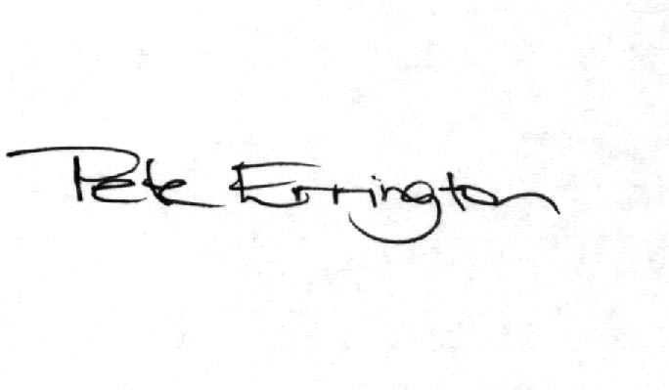

Pete Errington
Home Builders Federation
Regional Policy Manager (South, East & London)

