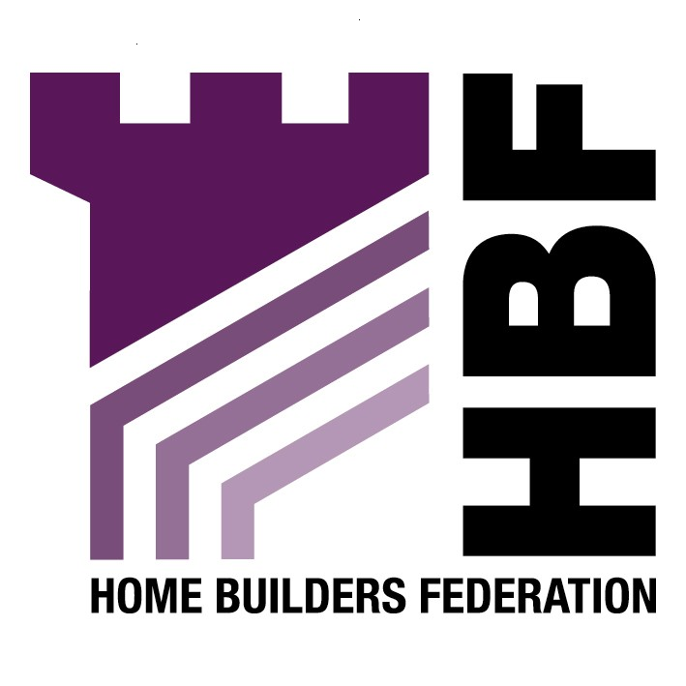

Emailed to planning.policy@northtyneside.gov.uk

North Tyneside Council
Station Road
Killingworth
Newcastle
NE12 6WJ

21 August 2007

Dear Sir or Madam

Sustainable Development and Construction Guide Informal Statement of Planning Policy

Thank you for giving the Home Builders Federation (HBF) the opportunity to comment on the above document. The HBF have considered the proposed document and have made the following observations:

General

The Home Builders Federation and Britain’s home building industry is working together with the Government to start addressing how to deliver the Government’s ambitious attempt to deliver higher environmental standards. However, home builders cannot achieve them alone. HBF and other parties have begun the crucial task of working out how we can achieve higher environmental standards and at the same time deliver the step-change in housing output that the country so badly needs. The house building industry has set itself the challenge for all new homes to be zero carbonby 2016.

HBF considers focus should be on the overall objectives of carbon reduction and the details of how to deliver this objective. The Code for Sustainable Homes should be used as a single national standard, other local requirements and details of specific technologies, such as those set out in this informal statement of planning policy are not helpful in achieving the overall goal to reduce carbon emissions.

The draft PPS: Planning and Climate Change (supplement to PPS1) paragraph 31 states ‘planning authorities should not need to devise their own standards for the environmental performance of individual buildings as these are set out nationally through the Building Regulations. Higher standards for new homes are set out in the Code for Sustainable Homes. Where planning authorities wish to require higher levels of building performance, because of local development or site specific opportunities, the expected local approach should be set out in advance in a development plan document. For new homes, local standards should be based on the Code for Sustainable Homes’.

Therefore, the HBF believes it to be more appropriate to set environmental standards through this National Code, rather than using local guidance and the checklist at the back of the guidance to force through premature standards.

Energy Supply

The section again fails to take on board the fact that many sustainable design matters will very soon be covered by the Code for Sustainable Homes, and that in order to reduce CO2 emissions, renewables provision on site might not be the most appropriate means of achieving this overall reduction, either technically or financially. Any requirement for renewable energy provision upon new development should be delivered through the higher stages of the Code for Sustainable Homes. As this is a framework and timescale to which the industry is committed to delivering. The HBF consider that the application of locally based energy performance standards would be unhelpful in facilitating the broader delivery of higher energy performance and consumption standards from new housing. There is a danger that new technologies may be introduced prematurely to address locally imposed requirements rather than using nationally proven methods.

Accessibility and Movement

The HBF would like to emphasise that development density should be determined on a site by site basis, depending on local circumstances.

Recycle and Reuse Buildings and Land

Although there is no actual acknowledgement that Greenfield development is both necessary and, in many circumstances, appropriate, PPS3 paragraph 65 suggests that, if performance of housing provision fails to meet trajectories or assumptions, planning authorities might have to update the quantity and mix of different categories of land within their housing land supply.

Although PPS3 paragraph 67 suggests that LPA’s will be able to refuse the release of Greenfield sites in order to ensure that brownfield sites are brought forward for development this is only the case where they can show that they have taken steps to remove the obstacles to the brownfield land’s development.

Equal consideration should be given to both Greenfield and brownfield and the merits of each should be taken into consideration i.e. certainty of delivery, sustainability.

Thank you again for giving the HBF the opportunity to comment. We trust you will take our comments into account and look forward to receiving further information regarding the progress of the document.

Yours faithfully,

Laura Edwards

Laura Edwards (maternity cover for Gina Bourne)
Regional Planner – Northern Region

Home Builders Federation

