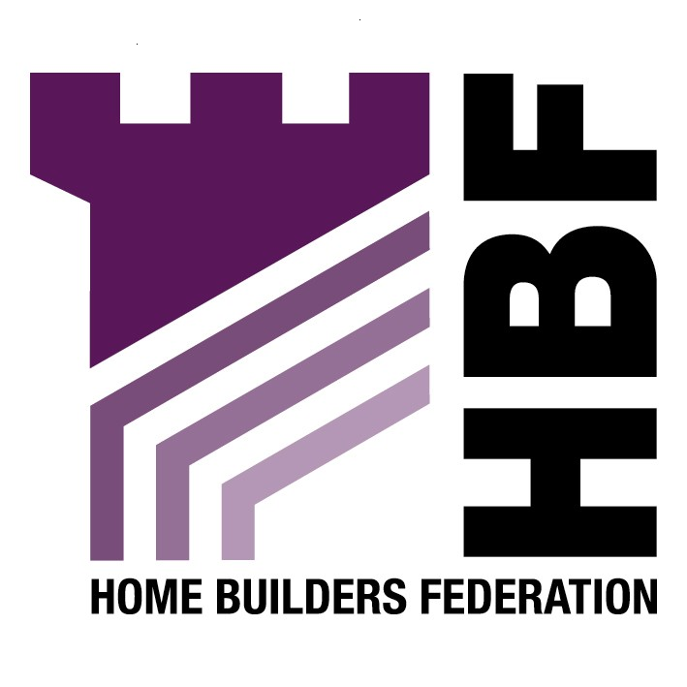

Emailed to cmyers@sedgefield.gov.uk

Forward Planning Team
Neighbourhood Services
Sedgefield Borough Council
Council Offices
Spennymoor
DL16 6JQ

28 August 2007

Dear Sir or Madam

Incorporating a Renewable Energy Obligation into Developments

Thank you for giving the Home Builders Federation (HBF) the opportunity to comment on the above document. The HBF have considered the proposed document and have made the following observations:

6. The Renewable Requirement

The HBF objects to the inclusion of the requirement for all residential developments made up of over 10 dwellings to provide 10% of their energy requirement from renewable sources by 2010 and 20% by 2020. The document fails to take into account the fact that many sustainable design matters will very soon be covered by the Code for Sustainable Homes, and that in order to reduce CO2 emissions, 10% renewables provision on site might not be the most appropriate means of achieving this overall reduction, either technically or financially. In Sedgefield’s case it may be more appropriate to deliver this reduction through large scale wind farms.

In any case the HBF believe that any requirement for renewable energy provision upon new development should be delivered through the higher stages of the Code for Sustainable Homes. As this is a framework and timescale to which the industry is committed to delivering. The HBF consider that the application of locally based energy performance standards would be unhelpful in facilitating the broader delivery of higher energy performance and consumption standards from new housing.

11. Checklist

The HBF believes that this checklist is overly onerous on developers. The development industry has signed up to the target of all new homes being built to an agreed zero carbon standard by 2016. In order to achieve this, the industry should be able to rely on a clear national framework and timetable for the necessary changes in building regulations. This approach will enable industry to work with greater confidence and efficiency to find the best means of delivering homes to the new standard in the volumes needed.

The fundamental point is that we do not currently know how to achieve zero-carbon standards in any kind of meaningful volume. A proliferation of targets will harm our ability to innovate, test, prove and deliver in the numbers that we need to. It risks product and housing design failure, raising serious issues around warranties and insurance. In turn, it risks harming consumer confidence in both the process and the homes we deliver. Failure risks harming consumer confidence. We need local authorities to keep the code timetable. We share the aims of higher output and high performance standards. We must ensure that in achieving one of these, the other is not undermined.

Thank you again for giving the HBF the opportunity to comment. We trust you will take our comments into account and look forward to receiving further information regarding the progress of the document.

Yours faithfully,

Laura Edwards

Laura Edwards (maternity cover for Gina Bourne)
Regional Planner – Northern Region

Home Builders Federation

