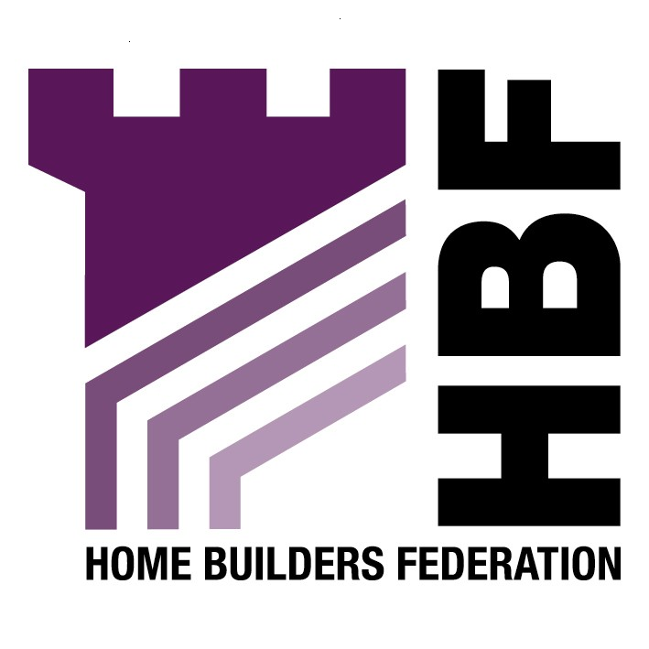

emailed to: ourfuture@ryedale.gov.uk

Ryedale District Council
Ryedale House
Malton
North Yorkshire
YO17 7HH

21 August 2007

Dear Sir or Madam

Core Strategy Consultation

Thank you for giving the Home Builders Federation (HBF) the opportunity to comment on the above document. The HBF have considered the proposed document and have made the following observations:

4. Housing Distribution
Question 8: Which option do you think is most appropriate? Why?

The HBF believes that these options are too prescriptive; a broad approach would give the core strategy more flexibility to deal with current and future circumstances as well as giving some flexibility to subsequent DPD’s in making detailed land allocations.

7. Housing Need and Affordable Housing

When determining how much affordable housing is required reference should be made to the results of a Housing Market Assessment rather than the Joseph Rowntree Foundation Study in this section. Any percentage requirement needs to be based on the findings of Housing Market Assessment for the area, which should be carried out in consultation with the development industry. The HBF is concerned that until this work is complete the Core Strategy is not founded on a robust and credible evidence base

The Council should ensure that a proper Housing Market Assessment is undertaken with the full involvement of the property industry in order to help underpin the evidence base for any policies and requirements. PPS3 (Annex C) gives the requirements of the outputs from Housing Market Assessments and states assessments should be prepared collaboratively with stakeholders, suggesting that the involvement of the industry is a key part of the methodology.

Question 16: Should we increase our affordable housing target?

Increased percentages of affordable housing on development sites are not conducive with achieving sustainable mixed communities as PPS3 or the Governments Sustainable Communities Plan suggests. There is a need to balance and mix communities and for that mix to include tenures that reflect the assessed needs of the market and not a aspirational figure that is imposed irrespective of urban and rural characteristics.

Should more affordable housing be required, the selling price of the market housing will need to be increased in order to cover the costs of providing more as the developer gets the least returns from this affordable housing products. This will ultimately widen the affordability gap. Therefore, it is essential that an appropriate balance be struck in order to balance needs.

Question 17: What level of affordable housing do you think we should seek? Why?

In relation to the level of affordable housing provision, proper and full regard must be had to the overall viability of schemes in setting any requirements. It should be remembered that in order to make housing more affordable, there needs to be more housing built in total. There should also be a flexible approach to the delivery of any affordable housing requirement, taking on board whether or not public grant funding is available. If not, then an alternative approach/requirement has to be properly considered. Therefore, the HBF believes that affordable housing provision should be determined on a site by site basis.

18. Should we set a separate target for Market Towns and Villages?

Affordable housing percentages should be determined on a site by site basis. Imposing blanket targets for market towns and villages might neglect local circumstances within the areas.

19. Should we lower the site size thresholds that will “trigger” the contribution?

No. The HBF regards an increase in housing supply as by far the most long term solution to housing under- supply and poor affordability thereby meeting the needs of all sectors of the community. It must be recognised that affordable housing requirements must not be so onerous that they threaten the delivery of the Council’s overall housing requirement. The Council has to consider a vital matter that, the very fact that thresholds are lowered is likely to reduce the supply of smaller sites coming to the market. Clearly any lower thresholds set will need to both comply with national guidance, and also be properly backed up by a sound evidence base.

Thank you again for giving the HBF the opportunity to comment. We trust you will take our comments into account and look forward to receiving further information regarding the progress of the document.

Yours faithfully,

Laura Edwards

Laura Edwards (maternity cover for Gina Bourne)
Regional Planner – Northern Region

Home Builders Federation

