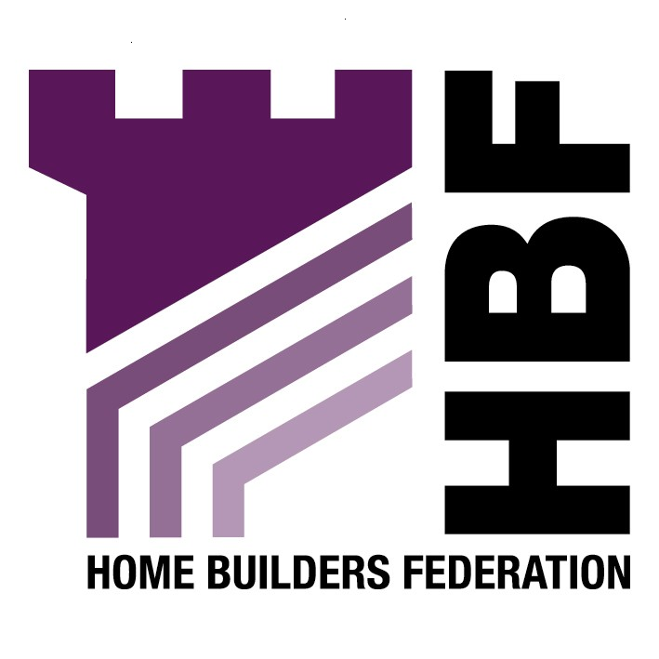

Emailed to Ingrid.Berry@planning.sefton.gov.uk

Planning and Economic Regeneration Director
Sefton Council
Magadalen House
30 Trinity Road
Bootle
Merseyside
L20 3NJ

18 June 2007

Dear Madam

Interim Planning Guidance- Requirements for New Housing in South Sefton

Thank you for giving the Home Builders Federation (HBF) the opportunity to comment on the above document. The HBF have considered the proposed document and have made the following observations:

Evidence Base

The HBF recognises that the Council is updating the policy based on new guidance such as PPS3, however, the HBF does not consider that the evidence base the interim policy is based on is up to date and robust. In accordance with Government guidance the Council should carry out a Strategic Market Assessment. Any percentage requirement needs to be based on the findings of a Housing Market Assessment for the area, which should be carried out in consultation with the development industry. The HBF believes that the interim affordable housing policy should not be adopted until this has been completed. Basing policy on the “Supply and Demand” Study may not be appropriate if it does not adhere to national guidelines and involve the house building industry sufficiently. Additionally the Housing Needs Assessment (2005) needs updating.

Paragraph 2.7

In seeking to determine what is an appropriate policy approach to securing affordable housing provision, consideration has to be given to the effects on overall housing supply. Particularly the viability of development sites which is a key theme of PPS3. Setting a higher percentage target or lower site size threshold is wholly counter productive if that target / threshold impacts on development viability and so prevents sites coming forward. Or, if achieving that target means compromising so heavily on other policy objectives and planning obligation requirements that the overall quality of development is adversely affected. The local circumstances of the site also has a large impact on how viable/ appropriate it is to provide affordable housing. Therefore, the HBF recommends flexibility when determining affordable housing provision and would advise against setting a blanket target of 30% on developments for 15 or more dwellings.

It is not for the Council to dictate precise levels of housing mix, this is something that only the market can address taking on board the latest information in respect of the types of housing sought in each housing market area. The target for 89% of affordable housing provision to rent and 11% to be intermediate housing may not always be appropriate. Therefore, the HBF would like to emphasise that this should be determined on a site by site basis.

Paragraph 2.20

With regard to the requirement that all new housing development should be “lifetime homes” there are a number of means of providing access and flexibility without specifically requiring lifetime homes. The option should require the provision of flexibility, without detailing the need for “lifetime homes”.

Paragraph 2.21

The HBF considers that the requirements for new housing to meet at least Level 3 of the Code for Sustainable Homes to be premature. The development industry has signed up to the target of all new homes being built to an agreed zero carbon standard by 2016. In order to achieve this, the industry should be able to rely on a clear national framework and timetable for the necessary changes in building regulations. This approach will enable industry to work with greater confidence and efficiency to find the best means of delivering homes to the new standard in the volumes needed.

It has been acknowledged in various studies recently that it takes a long time for a developer to obtain planning permission and that, if anything, that time is getting longer rather than shorter. For large development we are looking at many years and even relatively modest developments can take 18-24 months from initial pre-application discussions with an authority to the issuing of final consent. Given that timescale and the nature of the negotiations and financial commitments developers have with landowners, the rules simply cannot change overnight. The achievement of Code Level 3 is estimated to add between £3,000 and £5,000 to the cost of a dwelling. And that is not the additional cost over current minimum building regulations standards. That is the cost over achieving EcoHomes Very Good standard. You can add another £2,000 per unit to account for the difference between current building regs and EcoHomes very good. So that is an additional cost burden of £5,000 to £7,000 per dwelling which has not been factored into any land price calculation or negotiation.

The only possible outcome of imposing such a requirement can be to delay or stymie development at a time when under-supply of housing and the impacts of that on affordability and quality of life etc in the region, is endemic in this part of the world. Developers will have to either go back to landowners and re-negotiate financial contracts (which landowners may not be willing to do) which will, at best, add further delay. At worst it will result in sites being tipped over the balance in terms of viability. It is not just an issue of £5,000 to £7,000 per unit. It is the plethora of other s106 obligations local authorities load on to new development (some appropriate, many not), not least of which is the obligation to provide high levels of affordable housing, which add to the burden. Something has to give and if this new Code 3 requirement is to be brought forward immediately then authorities will have to compromise on other s106 financial requirements or sites will not be developed. That is absolutely the opposite of what Government planning policy is setting out to achieve.

i) Developer Contributions through “Section 106” Agreements”

Paragraph 5.5

The HBF objects to the developer having to undertake a full financial appraisal of the scheme and this being assessed by an independent financial consultant. Authorities can seek to negotiate with developers and can request open book accounting but it cannot expect or require it. Furthermore, different developers and development schemes will operate to different cost and profits and it will be difficult for a third party to comment on what is, and what is not, financially appropriate.

Thank you again for giving the HBF the opportunity to comment. We trust you will take our comments into account and look forward to receiving further information regarding the progress of the document.

Yours faithfully,

Laura Edwards

Laura Edwards (maternity cover for Gina Bourne)
Regional Planner – Northern Region

Home Builders Federation

