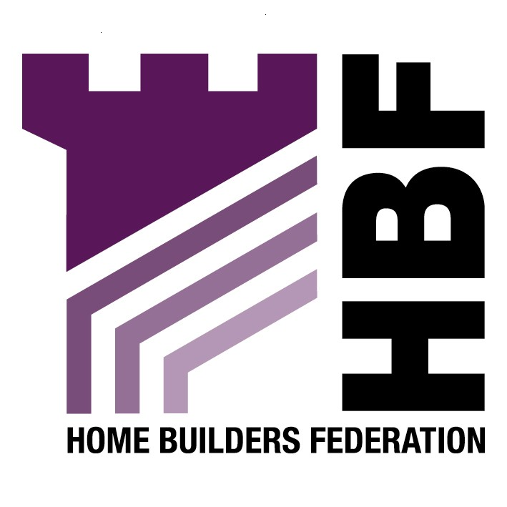

emailed to planningpolicy@wigan.gov.uk

Environmental Services Department
Wigan Council
Civic Buildings
New Market Street
Wigan
WN1 1RP

04 June 2007

Dear Sir or Madam

Development and Air Quality SPD

Thank you for giving the Home Builders Federation (HBF) the opportunity to comment on your Draft Supplementary Planning Document for Development and Air Quality. The HBF have considered the proposed document and have made the following observations:

Appendix B: Recommended mitigation measures and standards for developments of varying scale

Residential Developments

The HBF objects to the inclusion of Eco Homes rating in the document. This fails to take into account the fact that many sustainable design matters will very soon be covered by the Code for Sustainable Homes. The HBF believe that any requirement for renewable energy provision upon new development should be delivered through the higher stages of the Code for Sustainable Homes. As this is a framework and timescale to which the industry is committed to delivering. The HBF consider that the application of locally based energy performance standards would be unhelpful in facilitating the broader delivery of higher energy performance and consumption standards from new housing.

The HBF objects to the inclusion of a 10% renewables provision on site, as this has proven to be unworkable. It might not be the most appropriate means of achieving this overall reduction, either technically or financially.

There must come a point at which, if we are to make real efficiency gains, more attention is diverted to the real culprit, namely the existing stock, rather than constantly going for the easy option of further restrictions on new building. These requirements are making new homes ever more expensive at a time when affordability is a very serious concern.

This policy approach should be worded flexibly in recognition of these concerns. There should not be hard and fast requirements for achieving non-statutory and unenforceable criteria. The policy approach should concern itself with the spatial implications of land use rather than involving itself in matters best left to other regulatory processes. Additionally any matters of importance to development costs will instead need to be clearly set out in a Development Plan Document (DPD), rather than being delegated down to a SPD. Given that they could potentially have a significant impact on development viability, they must instead be dealt with in DPD’s and subject to the appropriate public scrutiny bestowed upon these.

Thank you again for giving the HBF the opportunity to comment. We trust you will take our comments into account and look forward to receiving further information regarding the progress of the document.

Yours faithfully,

Laura Edwards

Laura Edwards (maternity cover for Gina Bourne)
Regional Planner – Northern Region

Home Builders Federation

