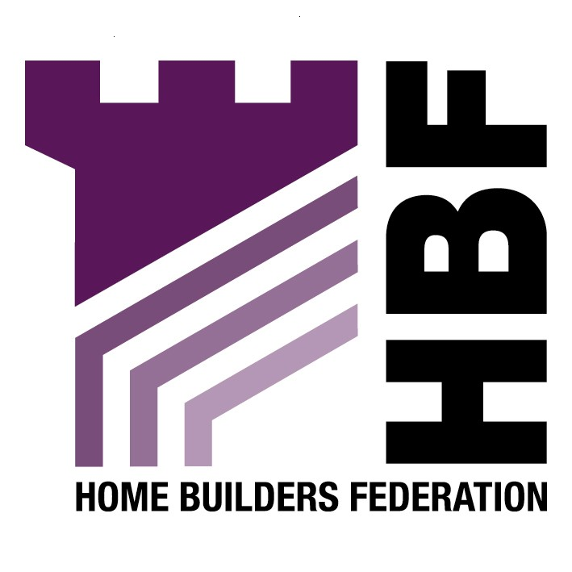

Emailed to ldf@leeds.gov.uk

Planning and Economic Policy
The Leonardo Building
2 Rossington Street
Leeds
LS2 8HD

Dear Sir or Madam

City Centre Action Plan- Preferred Options

Thank you for giving the Home Builders Federation (HBF) the opportunity to comment on your Draft Supplementary Planning Document for City Centre Affordable Housing. The HBF have considered the proposed document and have made the following observations:

General Comments

The HBF notes that this Area Action Plan fails to conform with the general approach of the adopted UDP, which not only undermines the UDP but also predetermines the development strategy to be contained within the Core Strategy. This intended approach runs contrary to advice contained in PPS12 that states;

“The Core Strategy should set out key elements of the planning framework for the area. ….It should normally be the first development plan document to be produced, except where the local planning authority has up-to-date saved policies and where the priority in the local development scheme is the preparation of an area action plan or other development plan document”. (Paragraph 2.9)

Evidence Base

The HBF objects to the fact that this AAP consultation document has been produced ahead of the publication of a number of key evidence base documents, such as the Strategic Flood Risk and Housing Market Assessment. This does not comply with the requirements of PPS12, and leads the HBF to question the identification of preferred options without such an evidence base. Additionally it makes it more difficult for consultees to formulate responses without these documents being available to view.

Strategic Flood Risk

The City Centre AAP has the potential to deliver a substantial amount of development within AAP boundary, a large proportion of which is a high flood risk zone. The HBF notes that the suggested approach within the AAP fails to conform to the sequential approach as advised in PPS25 in that alternatives need to be considered outside the AAP boundary, and that the Strategic Flood Risk Assessment is unavailable to consultees as part of this consultation process and is currently being amended. The HBF believes this to be unacceptable.

Housing Market Assessment 2007

Similarly the document has the potential to deliver substantial amounts of residential development of a very limited type with little or no regard to the type of housing required by the District as a whole. Without proper reference to the Housing Market Assessment the HBF believes this approach to be unsound.

Providing Housing
PO-07

With regard to the requirement that a proportion of housing development should be “lifetime homes” there are a number of means of providing access and flexibility without specifically requiring lifetime homes. The option should require the provision of flexibility, without detailing the need for “lifetime homes”.

PO-17

The HBF draws attention to the “Building for Life” document produced in consultation with CABE. This document is available to download on our website.

Renewable Energy

PO-22

The HBF objects to the inclusion of the 10% energy generation rule in this document. This has proven to be unworkable, and may not always be the most appropriate method of reducing carbon emissions either technically or financially. The aspirational figures for increasing this figure are believed to be unrealistic. Furthermore, it may not be suitable for all sites to provide on site renewable energy due to the site’s location, geology etc. In some cases it may be better to contribute to a large-scale renewable energy scheme that would provide more energy to a greater number and would also require less maintenance. It is considered that the Local Planning Authority should look at such issues more strategically over a longer-term. It should also be considered on a site-by-site basis rather than implementing a blanket policy as one size does not fit all.

Sustainable Materials and Construction

PO-23

The HBF notes that reference to BREAAM for housing should not be included, as this will be superseded by the Code for Sustainable Homes, as this is a framework and timescale to which the industry is committed to delivering. The HBF considers that the application of locally based energy performance standards would be unhelpful in facilitating the broader delivery of higher energy performance and consumption standards from new housing. There is a danger that new technologies may be introduced prematurely to address locally imposed requirements rather than using nationally proven methods.

The HBF believes there must come a point at which, if we are to make real efficiency gains, more attention is diverted to the real culprit, namely the existing stock (160,000 new homes vs. 25 million existing stock- under 1%), rather than constantly going for the easy option of further restrictions on new building. These requirements are making new homes ever more expensive at a time when affordability is a very serious concern. Putting restrictions on such a low threshold of dwellings will inevitably affect the viability of schemes and therefore, could be holding up the delivery of new homes.

Public Open Space and Development

PO- 25

The HBF objects to specifying the number of dwellings/ size of site when determining whether open space should be required. This blanket approach does not take into account the individual nature of sites; for example if there is surplus open space within an area, a development should not be required to provide any further open space. Furthermore, a development should only provide for open space when ‘it is directly related to the proposed development’ (Circular 05/05). A development should not be required to provide facilities in order to satisfy a deficiency within the locality.

The HBF does not object to some amount of flexibility when deciding where developer contributions are located, as it may not always be appropriate on site.

The HBF objects to the developer having to cover the cost of 10 years of maintenance of public open spaces, as it believes this to be too onerous, and not their responsibility. It is vital that any planning obligation is subject to the five tests of soundness as outlined in Circular 05/2005.

Public Realm and Environmental Improvements

PO-27

See above objection.

Thank you again for giving the HBF the opportunity to comment. We trust you will take our comments into account and look forward to receiving further information regarding the progress of the document.

Yours faithfully,

Laura Edwards

Laura Edwards (maternity cover for Gina Bourne)
Regional Planner – Northern Region

Home Builders Federation

