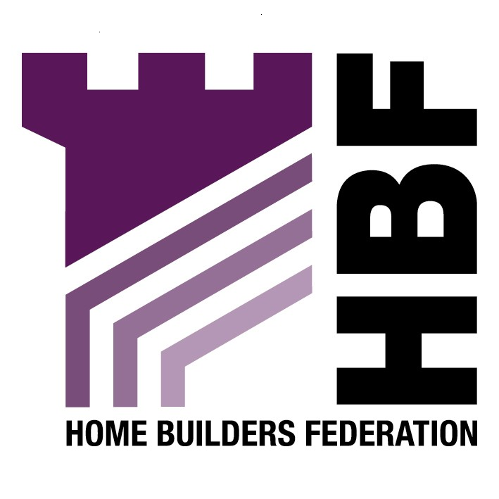

Emailed to ldf.consultation@bradford.gov.uk

Department of Regeneration, Plans and Performance
8th Floor
Jacobs Well
Bradford
West Yorkshire
BD1 5RW

03 April 07

Dear Sir or Madam

Draft Supplementary Planning Document: Planning Obligations

Thank you for giving the Home Builders Federation (HBF) the opportunity to comment on your Draft Supplementary Planning Document for Planning Obligations. The HBF have considered the proposed document and have made the following observations:

Firstly, any matters of importance to development costs will instead need to be clearly set out in a Development Plan Document (DPD), rather than being delegated down to a SPD. Given that they could potentially have a significant impact on development viability, they must instead be dealt with in DPD’s and subject to the appropriate public scrutiny bestowed upon these.

5.0 Procedure for Negotiating Planning Obligations

Pre- application Discussion Stage

The HBF is soon to publish “Pre application Discussion Good Practice Guidance” which is prepared in conjunction with the Planning Officers Society and the British Property Federation. This document should be acknowledged within the SPD.

Application Appraisal Stage

In relation to this policy which requires an open book, spreadsheet- based development appraisal to accompany the scheme proposed. The HBF is fundamentally opposed to such a requirement, which goes way beyond the remit of Town and Country Planning legislation and is, in effect an attempt to set a level of developer profit by imposing a land tax on development, which we believe to be illegal. Authorities can seek to negotiate with developers and can request open book accounting but it cannot expect or require it. Furthermore, different developers and development schemes will operate to different cost and profits and it will be difficult for a third party to comment on what is, and what is not, financially appropriate.

Part Two: Areas for Intervention

Overall the HBF believes that the planning obligations set out in this document are too prescriptive. It is crucial that any planning gain requirements are fully considered in relation to site viability. Whilst the public inevitably wants developers to fund all sorts of facilities and services in their areas, it must be remembered that developers can only be asked to fund these where need directly relates to new development. Furthermore, if planning gain requirements are unrealistic then landowners won’t sell their sites, and developers won’t find them profitable enough to develop. As a direct consequence, the Council would then be likely to struggle to meet it’s housing supply requirement. It would also then fail to meet its responsibility to meet the housing requirements of the whole community. Indeed, such a situation would result in worsening affordability problems.

Circular 5/2005

The HBF draws attention to Circular 5/2005 sets out five ‘tests of reasonableness’ which requires all planning obligations sought by authorities to be:
- necessary
- relevant to planning
- directly related to the proposed development
- fairly and reasonably related in scale and kind to the proposed development and
- reasonable in all other respects.

Circular 5/2005 (paragraph B5) clarifies that in order to be acceptable planning obligations sought must satisfy all five of these tests. The HBF believes many of the policies set out do not satisfy all five of these tests, and will detail why in the following sections.

Affordable Housing

The affordable housing requirements are too specific, HBF advocates a more flexible approach to determining affordable housing percentages. Any affordable housing requirement must seek to take on board the overall viability of schemes (including the likely availability or not of grant funding) and will need to consider the full range of other planning gain requirements likely to be sought. Unrealistically high affordable housing requirements could severely threaten overall housing delivery rates.

Education

The HBF considers that this is a relevant planning condition. However, at the same time are concerned as to the very substantial contributions, which are required to satisfy this planning obligation. Overall, there are more households due to an ageing population etc. Therefore, there are no additional people to cater for and there should be no additional contribution.

Open Space and Recreation

The HBF objects to specifying the number of dwellings when determining whether open space should be required. This blanket approach does not take into account the individual nature of sites; for example if there is surplus open space within an area, a development should not be required to provide any further open space. Furthermore, a development should only provide for open space when ‘it is directly related to the proposed development’ (Circular 05/05). A development should not be required to provide facilities in order to satisfy a deficiency within the locality.

Public Art

While the objective of seeking to secure public art in major developments is a laudable one in policy, what is now proposed in this draft SPD is too prescriptive and goes way beyond what is stipulated in policy and way beyond the remit of the town and country planning legislation. Therefore, for it to be a hard and fast requirement of new development over what is a very low site size threshold is unreasonable and excessive. It is certainly not required in order for development to proceed and does not meet the 5/2005 tests. The SPD must be brought back into line with the policy which recognises that public art is something which is desirable rather than necessary. It certainly cannot be justified in every case.

Public Realm

The HBF draws attention to the “Building for Life” document produced in consultation with CABE. This document should be acknowledged within the SPD. It is available to download on the HBF website.

Transport and Travel

New development must only be required to contribute to provision required to meet the genuine need it creates and must not be expected to contribute to any existing shortfall. This is a fundamental requirement of Circular 05/05 and should be clearly stated in the proposed contribution requirement. Therefore, the HBF objects to the onerous requirements set out in this policy.

Thank you again for giving the HBF the opportunity to comment. We trust you will take our comments on board and look forward to receiving further information regarding the progress of the document.
Yours faithfully,

Laura Edwards

Laura Edwards (maternity cover for Gina Bourne)
Regional Planner – Northern Region

Home Builders Federation

