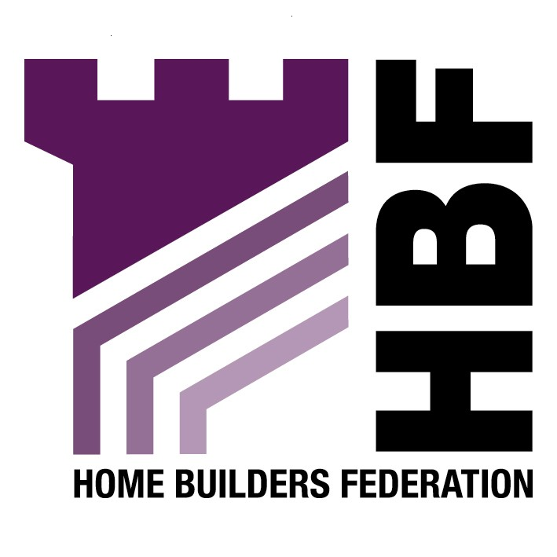
Emailed to lucy.hughes@epnbc.gov.uk

Planning Policy and Projects
Ellesmere Port and Neston Borough Council
4 Civic Way
Ellesmere Port
Cheshire
CH65 OBE

08 May 2007

Dear Madam

Draft Supplementary Planning Document: Open Spaces

Thank you for giving the Home Builders Federation (HBF) the opportunity to comment on your Draft Supplementary Planning Document for Open Spaces. The HBF have considered the proposed document and have made the following observations:

Chapter 6: Planning Obligations

It is crucial that any planning gain requirements are fully considered in relation to site viability. Whilst the public inevitably wants developers to fund a variety of facilities and services in their areas, it must be remembered that developers can only be asked to fund these where need directly relates to new development. Furthermore, if planning gain requirements are unrealistic then landowners won’t sell their sites, and developers won’t find them profitable enough to develop. As a direct consequence, the Council would then be likely to struggle to meet it’s housing supply requirement. It would also then fail to meet its responsibility to meet the housing requirements of the whole community. Indeed, such a situation would result in worsening affordability problems.

Any matters of importance to development costs will instead need to be clearly set out in a Development Plan Document (DPD), rather than being delegated down to a SPD. Given that they could potentially have a significant impact on development viability, they must instead be dealt with in DPD’s and subject to the appropriate public scrutiny bestowed upon these.

Thank you again for giving the HBF the opportunity to comment. We trust you will take our comments on board and look forward to receiving further information regarding the progress of the document.

Yours faithfully,

Laura Edwards

Laura Edwards (maternity cover for Gina Bourne)
Regional Planner – Northern Region

Home Builders Federation

