

Claire Coles

Senior Consultant BY EMAIL ONLY

Entec UK Ltd

Atlantic House

Imperial Way

Reading

RG2 0TD

31st May 2007

Dear Mrs Coles,

URBAN HOUSING CAPACITY STUDY

LONDON BOROUGH OF WALTHAM FOREST

Thank you for consulting the Home Builders Federation (HBF) on your draft scoping report for the above study.

HBF is pleased at the early engagement with stakeholders on this study and at the council’s desire to take on board matters related to marketability and deliverability. However, having said that, HBF also has a number of serious concerns about the study. Mainly in that it is neither one thing nor another. It is neither a housing land availability assessment (HLAA) nor a housing market assessment (HMA) yet PPS3 is clear that it is HLAAs and HMA which should comprise the evidence base in support of policies and proposals in Development Plan Documents, There is no scope, under current Government guidance, for housing capacity studies to inform the decision making process. At the very outset, and at the very least, the study should explain why the council has sought to undertake an old-fashioned UCS rather than doing what it is required to do under current guidance and carry out an HLAA and an HMA. All the comments set out below follow from this fundamental point that we do not believe the council should be carrying out a UCS.

Firstly, HBF is concerned at the ‘disclaimer’ given in the 5th paragraph on page 1 of the scoping report which suggests that the council will not necessarily grant planning permission for residential development on any site identified in the study. Given the emphasis in PPS3 on deliverability, if a site is not considered acceptable for housing by the local planning authority it should not be included in the assessment. Or rather, if it is included in the assessment it should be made clear that it is not suitable for development and should be excluded from the supply projections and housing trajectory. PPS3 requires assessments of sites to robust and realistic.
If this study is to be used to inform future DPDs it must only put forward sites that are deliverable, which, as paragraph 54 of PPS3 makes clear, means available, suitable and achievable. On that basis, sites included in the assessment which are not clearly discounted through the process of carrying out the study due to their undevelopability, should all be considered acceptable for housing. The methodology should be amended to make this clear.

On the basis of the above, therefore, HBF’s answer to Key Questions 1 and 3 are that the approach is not acceptable. The council should not be carrying out an urban capacity study. It should be carrying out a housing land availability assessment (to be supplemented in due course by a housing market assessment) and use these in the context described in PPS3 rather than adopting the out of date PPG3 approach. This is about more than semantics; it is about the process and context by which the data will be collected and used which are entirely different under PPS3 than they were under PPG3.

Secondly, turning to the methodology itself (section 3), this affirms our belief that it is inappropriate for the council to carry out an urban capacity study. An urban capacity study is not a HLAA. An HLAA and the approach to evidencing the policy base clearly set out in PPS3 means that the assessment should only be dealing with sites which are deliverable. The sites and the numbers attributed to them should be realistic and achievable. There is no scope in under PPS3 to deal with theoretical or unconstrained capacity. The capacity identified in the study should be all of the “….ables” set out at paragraph 54 of PPS3. This “unconstrained capacity” stage should be deleted from the methodology and the assessment should only consider what is likely to be achievable on the ground.

Thirdly, dealing with Key Question 4 and the sources of supply, HBF would remind the council that the approach should set out to identify as much potential capacity as possible. PPS3 is clear (and it has subsequently been further clarified in a recent CLG statement to local and regional planning authorities) that windfalls should not be included in housing trajectories other than in exceptional local circumstances (paragraph 59). Exceptional local circumstances does not mean that, just because the council has always counted windfalls this can continue. That is not an exceptional local circumstance as all authorities have, in the past, included windfall allowances. Exceptional local circumstances relate to the nature of the sites likely to come forward. Hence the need to identify as much of the potential supply as possible.

Therefore, while it is perfectly acceptable for the assessment to address the issue of windfalls, PPS3 is clear that they cannot be included in housing trajectories and assessments of land supply. This must be made clear in the methodology and the presentation of the final results.

Fourthly, turning to section 4, again, since we believe it is no longer appropriate for the council to be carrying out an urban capacity study, references to Tapping The Potential are irrelevant. As the report itself notes in a preceding section, Tapping The Potential has been cancelled by PPS3. Approaching this assessment on the basis of an old Tapping The Potential approach of unconstrained and constrained capacity and discounting and so on is old hat and fundamentally the wrong approach to be taking.

Fifthly, it is HBF’s view that the scoping report is very weak in explaining how it will factor in developability and market considerations into the methodology. This is a major concern to HBF. The report simply refers to what cancelled Government advice in Tapping The Potential said. It says nothing about what the council or the assessors will actually do or take into account in assessing developability other than testing a small sample of sites against a development costs spreadsheet.

Whilst acknowledging that this is just a scoping report, it gives no real detail on how it will take on board the views of house builders, landowners or estate agents about whether the types of sites identified are the types of sites they are interested in bringing forward or on which there is likely to be a demand to live. It says nothing about taking on board the views of the likely purchasers of new housing in the borough. It says nothing in any detail about the costs associated with bringing forward sites for development. It says nothing about alternative use values. It says nothing about the costs imposed on new development by local authorities in the form of affordable housing and other planning obligation and infrastructure requirements, tariffs, taxes and so on. Whilst affordable housing is mentioned briefly, other planning obligations are not. All of these considerations have a major impact on whether a site is likely to be deliverable.

The final methodology must spell out very clearly how, what, why, when and who will be involved in factoring in these vitally important considerations. If it does not, the assessment will not be fit for purpose. It will not, therefore, comprise robust evidence which can be used to demonstrate the soundness of any policy approach or allocation from which it is derived.

In answer to questions 8 & 9, therefore, HBF does not believe that discounting is either needed or appropriate and would not even be an issue for discussion if the council was doing what it should which is carrying out an HLAA rather than an urban capacity study. Similarly, with regard to deciding when sites will be likely to come forward for development, it is not for the council or its consultants to unilaterally determine this. The HLAA approach requires the full and proper co-operation of local house builders and developers in reaching a view about the future housing trajectory.

I hope these important matters can be taken on board prior to the council fully embarking on this work. Given the serious flaws in the proposed approach HBF would advise that the council abandoned this work and, instead, carried out a housing land availability assessment as required under PPS3. That is certainly the case if it wishes to avoid abortive work and incurring unnecessary costs.

Yours sincerely,
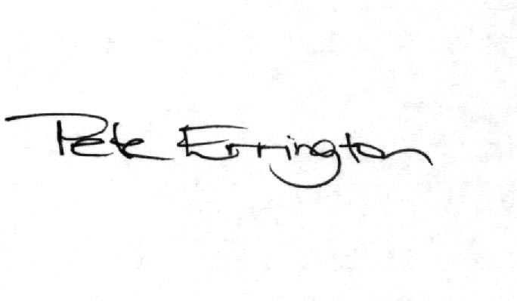

Pete Errington
Home Builders Federation
Regional Policy Manager (South, East & London)

