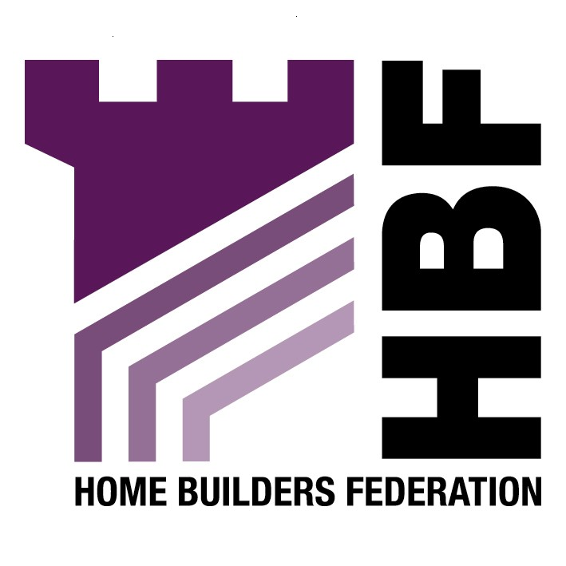

Emailed to: citydevelopment@york.gov.uk

Sustainable Design and Construction SPG,
City of York Council,
City Strategy,
York,
YO17ZZ

16 April 2007

Dear Sir or Madam

Sustainable Design and Construction Draft SPG

Thank you for giving the Home Builders Federation (HBF) the opportunity to comment on your draft Urban Design Guide SPG. The HBF have considered the document and have made the following observations:

The Home Builders Federation comments relate to two general issues, firstly that the council is dealing with sustainable design and construction issues at the local level and secondly that they are dealing with the issues as a SPG not a DPD.

The Home Builders Federation and Britain’s home building industry is working together with the Government to start addressing how to deliver the Government’s ambitious attempt to deliver higher environmental standards as well as a significant increase in numbers. The home building industry broadly welcomes the Government’s environmental targets. However, home builders cannot achieve them alone. HBF and other parties have begun the crucial task of working out how we can achieve higher environmental standards and at the same time deliver the step change in housing output that the country so badly needs. The house building industry has set itself the challenge for all new homes to be zero carbon within 10 years. We would stress that sustainability standards are already being set by Building Regulations and the new Code for Sustainable Homes. The Council’s planning policies should not seek to replicate or replace these (as PPS1 makes clear). The Code will supersede Ecohomes. Therefore, HBF considers that planning authorities should focus on the overall objectives of carbon reduction and the details of how to deliver this objective. Additionally the Code for Sustainable Homes should be used as a single national standard.

The draft PPS: Planning and Climate Change (supplement to PPS1) paragraph 31 states ‘planning authorities should not need to devise their own standards for the environmental performance of individual buildings as these are set out nationally through the Building Regulations. Higher standards for new homes are set out in the Code for Sustainable Homes. For new homes, local standards should be based on the Code for Sustainable Homes.

Paragraph 1.8 of PPS12 makes it clear that planning policies should not seek to duplicate or cut across matters more appropriately within the scope of other legislative regimes. Energy efficiency in building use and construction is manifestly the responsibility of the building regulations Part L. There has already been an extremely rapid improvement in performance over the past few years and new homes are now significantly more energy efficient than even recently built existing stock. There must come a point at which, if we are to make real efficiency gains, more attention is diverted to the real culprit, namely the existing stock, rather than constantly opting for the easy option of further restrictions on new building. These requirements are making new homes ever more expensive at a time when affordability is a very serious concern and also at a time when these features are not wanted by consumers. Efforts should be focused on changing public perception of the issue if this is not to be a very costly mistake.

The HBF considers that planning policies on issues such as sustainable design and construction should not be presented and considered simply as Supplementary Planning Guidance. Such policies could potentially have a seriously adverse effect on the viability of new developments and therefore should be examined independently as a Development Plan Document.

The policy guidance should be worded flexibly in recognition of these concerns. Improving the environmental standards of our homes should be achieved through standards set at the national level - the Code for Sustainable Homes and Building Regulations.

Thank you again for giving the HBF the opportunity to comment. We trust you will take our comments into account and look forward to receiving further information regarding the progress of the document

Yours faithfully,

Laura Edwards

Laura Edwards (maternity cover for Gina Bourne)
Regional Planner – Northern Region Home Builders Federation

