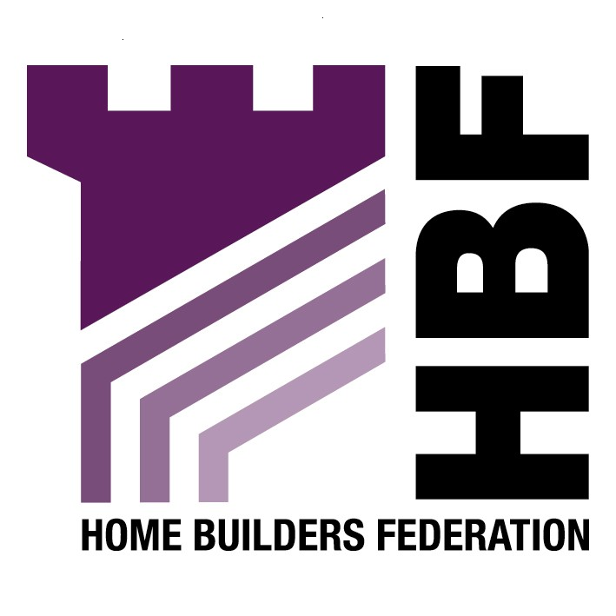

Emailed to brynroberts@gateshead.gov.uk

Bryn Roberts
Senior Planner
Gateshead Council
Civic Centre
Regent Street
Gateshead
NE8 1HH

17 April 2007

Dear Sir

Gateshead Town Centre- revised draft Planning Strategy

Thank you for giving the Home Builders Federation (HBF) the opportunity to comment on your revised draft Planning Strategy for Gateshead town centre. The HBF has considered the document and have made the following observations:

4) Creation of a Sustainable Town Centre

Energy

The HBF objects to the requirement that all significant new developments provide a minimum of 10% from renewable sources. This has proven to be unworkable and may not always be the best technical and financial solution to reducing carbon emissions. The aspirational target of 100% low carbon or renewable energy production on site within 15 years is unrealistic. The HBF consider that it is essential to ensure energy efficiency is maximised before considering renewable energy. Energy efficiency measures alone can reduce CO2 emissions and therefore it may not be necessary to explore renewable energy options. In addition, renewable energy technologies are not necessarily proven. Such products will need to be maintained and it is most likely that the lifetime of the development will considerably exceed the lifetime of most micro-generation and other renewables. Therefore the initial cost of the renewable does not represent a lifetime cost. In some cases it may be more beneficial to for large-scale developments to contribute to off site renewable energy generation than on site energy generation, which may be less effective. The HBF consider that the policy is inflexible.

New homes are already committed to reducing carbon output. The national requirements for improving the performance of dwellings is comprehensively set out in the Code for Sustainable Homes (December, 2006), Building a Greener Future: Towards Zero Carbon Development (December, 2006) and the industry/ government concordat for achieving Code level 6 for carbon reduction by 2016. It is important that all RPBs and LPAs: accept this framework as a legitimate national route for effective progress, and; do not take it upon themselves to try to move faster than the timetable outlined in the national documents above.

Construction and Design

The HBF would also like the document to recognise that the Federation in conjunction with CABE have produced the ‘Building for Life’ guide. This guide is intended to assist housebuilders, housing associations, architects and planners achieve good quality design in housing.

Materials

The HBF believe that the specifications for the materials used in construction are too onerous and may not necessarily be appropriate for developments. The materials should be determined on a site by site basis depending on the character and nature of the development.

Overall the HBF would like to emphasise the need to consider the viability of the scheme when setting requirements for construction and design; materials; equipment and the construction phase of site management. In a time when housing affordability is a key issue ensuring schemes are viable must be a high priority. Therefore, the HBF would warn against the prescriptive nature of many of the requirements in this document.

Thank you again for giving the HBF the opportunity to comment. We trust you will take our comments into account and look forward to receiving further information regarding the progress of the document.

Yours faithfully,

Laura Edwards

Laura Edwards (maternity cover for Gina Bourne)
Regional Planner – Northern Region

Home Builders Federation

