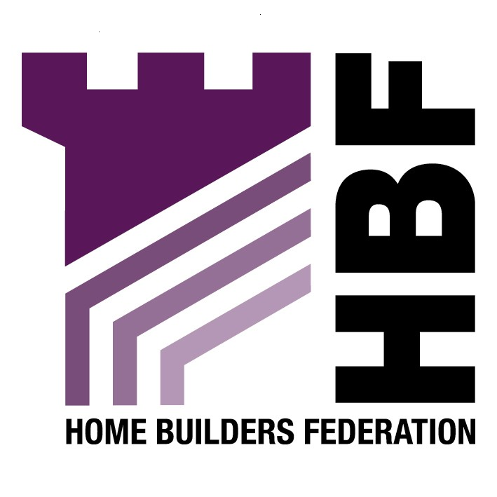
Emailed to strategic.planning@rochdale.gov.uk

Strategic Planning Team
Floor 2
Telegraph House
Baillie Street
Rochdale
OL161JH

Dear Sir or Madam

Submission Draft Statement of Community Involvement

Thank you for giving the Home Builders Federation (HBF) the opportunity to comment on your Submission Draft Statement of Community Involvement. The HBF has considered the document and have made the following observations:

Section 7

HBF supports the inclusion of traditional consultation techniques, namely formal letter and email notification of the availability of documents and the holding of events. Making documents available on the council’s website, for example, is only of benefit if stakeholders are in the practice of regularly checking the council’s website on the off-chance that something new has been announced. It is highly unlikely that most stakeholders will be in a position to do this. However, using emails or standard letters to inform stakeholders that documents are available or events are to be held is a vitally important aspect of the overall consultation and participation process.

Appendix F

We would welcome the inclusion of The House Builders Federation as an organisation to be consulted (Please be advised that The House Builders Federation is now trading as Home Builders Federation). In addition reference should be made to house builders/developers/landowners/planning and estate agents being involved in the planning process.

Thank you again for giving the HBF the opportunity to comment. We trust you will take our comments into account and look forward to receiving further information regarding the progress of the document.

Yours faithfully,

Laura Edwards

Laura Edwards (maternity cover for Gina Bourne)
Regional Planner – Northern Region

Home Builders Federation

