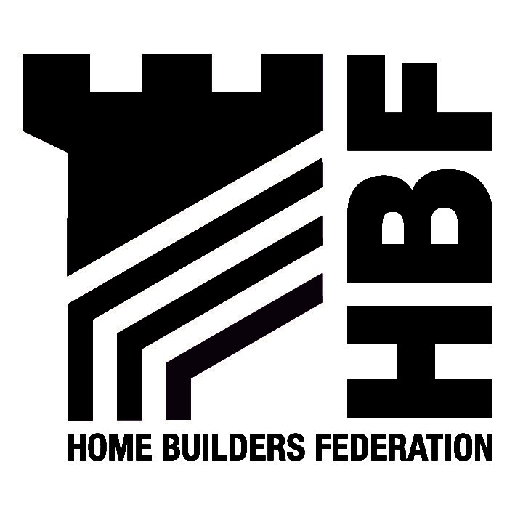

Mrs P Perceval-Maxwell
Panel Secretary
East Midlands Public Examination
The Belgrave Centre
Stanley Place, Talbot Street
Nottingham
NG1 5GG

Our ref: Respondent number 1210

23 March 2007

Dear Panel Secretary

Comment upon Draft Matters for EIP

Thank you for your invitation for the HBF to attend many of the sessions at the forthcoming EIP, as detailed on the Draft Matters. The HBF considers that as a voice for the majority of the private sector house building industry, it can offer a strategic over view on many aspects of the discussion and tap into members for further details where required. Nonetheless, it is disappointed to see that the draft matters timetable involves so few house builders/ their consultants.

The Plan is a challenging one, where housing growth is increasing beyond previous levels, and where the strategy is attempting to reverse many trends of past development. These challenges will need to be properly examined for soundness, and the HBF is concerned that a distinct lack of participants at the sessions (at just 14 people) may limit the discussion. The HBF considers that increasing the participants to numbers akin with other EIPs - for example the South West currently has 25 seats around the table, would enable a more balanced approach to discussion. The HBF recognises the Panels request for hot seating arrangements, however, considering the amount being proposed for discussion, the HBF is concerned that once it has made comment on a question/issue at a session, that should it wish to give its seat to a house builder for example for them to comment, that when the turn finally arrives for that person to contribute, the question will have been moved on – ‘the HBF effectively having already had its turn’, and the opportunity lost.

Deadlines for statements
The HBF is concerned that the deadline for statements has been set at 24th April and as yet, the final list of matters and questions for those statements to address, has not been agreed by the Panel. The opportunity for a full and constructive response to the matters in such a short period of time is therefore compromised. The HBF accepts the Panels request for statements to not exceed 2000 words, however considers this should apply to sub matters.

The HBF therefore would request that:
- The Panel have a staggered deadline for submission of further statements. The HBF would suggest a second deadline of the 3rd June could be used for those matters not being heard until the 19th June onwards. It is unlikely that the entire amount of paperwork will be read prior to the EIP commences, particularly on those later sessions for June and July. Similar staggered deadlines have worked effectively in the South East and South West EIPS recently.
- The HBF seeks clarification that matters and sub matters will have 2,000 word limits for each. Matters 4a, 4b and 4c for example, should each have a 2,000 word limit, rather than a 2,000 limit for the entire 11 questions at present. This also applies to matters 5, 6 and 7.

I will now address the draft matters themselves.

Matters 1 and 2
The HBF considers that these matters could both be covered in one and a half days, rather than the two and a half days on the draft timetable.

Matter 4
The HBF considers that this matter would benefit from a wider representation at the table. The current invitees only comprise 3-4 representatives that are pro-development. Separating the matter 4c from the matters 4a and 4b would allow for those concerned with Gypsy and Traveller provision to attend that session separately, and potentially free up a seat for another development sector colleague to attend matters 4a and 4b instead of the Gypsy and Travellers representative, who I do not feel would benefit from the discussions at 4a and 4b.

The HBF will not require a seat at 4c, and would be happy for this to be given to another participant.

The HBF considers that further questions should be added to those under matter 4. The following are suggested:
- Should the RSS contain within Policy 14, reference to the overall quantum of housing to be achieved within the Plan Period? Para 1.3 of PPS11 states that RSS should identify the scale of development for new housing, for a fifteen to twenty year period. The Plan only contains an annualised target at present and from the questions currently posed, this matter is not be addressed.
- Does the spatial distribution of housing respond to the latest information on household formation (the 2003 and 2004 Household Projections) and where those demands/needs are expected to arise?
- Does the RSS adequately deal with the variations in affordable housing circumstances, as required by PPS3, across the region?
- Does the RSS set out an approach to rural housing and rural affordable housing?

Matter 5
The HBF is concerned that the participants do not include development sector representatives from the house-building sector, and that HBF is the only housing participant. It is imperative that proper discussion is held that considers the linkages between housing and economic distribution. A developer seat to assist this process would be helpful. This would enable a participant from the technical sessions perhaps, to have an opportunity to speak at the table on this matter, should they feel they could contribute.

The HBF requests that an additional question that should be covered is
- Is the alignment between the RES and RSS sufficiently close?

Finally, the HBF would request that simple language is used within the questions, wherever possible to ensure clarity of understanding by participants. The word exogenous in matter 5a iv for example, could be replaced with ‘existing’. Other changes like this, to the remaining questions in the matters, could also be made.

Matter 6c
The HBF would like a seat at matter 6c, where it feels that a contribution would be helpful from a strategic house building perspective. The HBF is attending the sub area discussions and hence the question raised regarding Lincolnshire coast within this matter, directly relates to our responses to matter 11. If the matters 6a, 6b and 6c were divided as suggested earlier in this letter, the seat of Sport England for example on matter 6c is potentially one that HBF could have. It is not likely that Sport England will wish to attend 6c, but will have legitimate interests in 6a and 6B, where HBF does not.

Matter 7
Again, the division of these matters into separate sessions has helped. The HBF would like to request a seat at matter 7c. The need to deliver the challenging target of new homes, with reduced energy consumptions and improved efficiency is an agenda the HBF has signed up to with Central Government. The HBF is part of the Government task force for considering the barriers to achieving the 2016 target of zero carbon homes and considers that it can bring a balanced and considered view to the table on this matter. The policies in the RSS must be achievable and deliverable by all parties, and the focus on renewable energy providers at present may result in a rather biased discussion.

Matter 9
The HBF would like to suggest that this matter is divided into 3 sub matters, one for each of the three cities. This would have numerous benefits. The extra day saved by combining matters 1 and 2 together could be inserted here to provide more time for this valuable discussion.

It would also enable those with interests in one of the three cities to attend the session specific to them, and not need to sit through sessions on areas that may not concern them. This approach would also aid the local authorities, and district councils. In Derbyshire for example, council’s would have more opportunities to speak/have seats at a sub matter for Derby, than if they attend the sessions as currently drafted. Other council areas would benefit by having their own respective days.

The HBF would like confirmation that at least two development sector seats will be provided at this session, following the discussion of this point at the first preliminary meeting.

The HBF would suggest that at question ii in this matter, (and in matters 10, 11,12, and 14 – and hence I have not repeated this request below) be expanded to include;
- Has sufficient consideration been given to the impact of lead in times for larger development, on the required output for this sub regional area.

Matter 10
The HBF does not consider that the participants Ashby de la Zouch Civic Society and Derby and South Derbyshire Friends of the Earth, are relevant to a northern sub area discussion. Their interests lie outside of the northern sub area.

The HBF would like confirmation that at least two development sector seats will be provided at this session, following the discussion of this point at the first pre liminary meeting.

Matter 11
The HBF considers that the Eastern sub area outside of the Lincoln Policy Area, should have its own sub regional strategy. Without it, it is clearly lacking strategic direction. This issue should be addressed, and may be an issue for matter 1, and/or matter 11.

The HBF would like confirmation that at least two development sector seats will be provided at this session, following the discussion of this point at the first preliminary meeting.

The HBF would like to see additional questions within this matter. These are:
- Does the spatial distribution of housing within this sub area reflect its settlement characteristics?
- Questions relating to the growth areas at Newark, Grantham and Lincoln. These issues have been omitted by the Panel and yet will be fundamental in delivery.

Matter 12
The HBF would like confirmation that at least two development sector seats will be provided at this session, following the discussion of this point at the first preliminary meeting.

The HBF would like to see an additional question within this matter.
1. Does the spatial distribution of housing within this sub area reflect its settlement/ rural characteristics?

Matter 13
The HBF would request that further clarification is given regarding the questions in this matter.

What does ‘machinery for monitoring’ mean, within question i?

What ‘plan’ preparation does question ii refer to? The regional Plan or LDFs?

The HBF considers that an additional question should be asked, that relates to the requirements set in PPS11 on Implementation plans. The suggested question is:
1. Are the targets, indicators and mechanisms for monitoring, management and review processes appropriate?

The HBF notes that the Panel suggested at the Preliminary meeting, that a session would be allocated to cover the MKSM sub region, which is currently absent from the draft matters timetable.

I hope that the panel finds these comments useful and I look forward to receiving the revised list in due course.

Yours sincerely

JRussell

Miss Joanne Russell
HBF Regional Policy Manager

