

THE HOME BUILDERS FEDERATION

Sarah Clifford
Planning – Resources and Environmental Policy Division
Communities and Local Government
4/B1
Eland House
Bressenden Place
London. SW1E 5DU

7th March 2007

Dear Madam

CONSULTATION PLANNING POLICY STATEMENT (PPS)
PLANNING AND CLIMATE CHANGE

Thank you for consulting the Home Builders Federation (HBF) on the above draft PPS. The Home Builders Federation is the principal trade federation for private sector housebuilders in England and Wales. Its members range from very large, international companies through medium sized to small, local companies. These members account for approximately 80% of all new houses built in England and Wales in any one year.

The draft is obviously timely given the high level of interest in the subject of climate change both within government and the general public. However, following extensive consultation with our members we believe there remains some significant confusion in the drafting of the PPS in respect of the government’s policy stance on a number of the issues - and in particular, the proper role that planning policy should play within a much wider suite of policy and regulatory measures relevant to climate change objectives. In that sense, this response is also, of course, complementary to our response to the Building a Greener Future consultation and the work we are undertaking jointly with CLG through the 2016 Task Force.

HBF members have two key issues which we believe the PPS must address in a much clearer and transparent way than the current draft if the PPS is to help ensure an effective overall approach to tackling climate change as well as ensuring that we deliver the number of new homes required to tackle our national housing crisis.

These issues are the extent to which local planning authorities can include planning policies that seek particular levels of environmental performance from buildings (in particular, houses) and the requirement within the PPS that authorities should require at least 10% of energy use in a development to be generated locally from renewable sources.

Local Policies for Environmental Performance of Buildings

This first issue is becoming increasingly problematic for the housebuilding industry with the relationship between the Code for Sustainable Homes and planning policies being interpreted in an inconsistent way throughout England (and, indeed, Wales). In their attempt to be seen to be rising to meet the challenges set by climate change many regions, sub regions and local authorities are taking it upon themselves to try to move faster than the timetable attached to the Code for carbon reduction and that forms the basis of work by the housebuilding industry, the Government and others through the 2016 Task Force.

Examples such as the London Plan Alterations, the South West Regional Assembly’s proposed changes to the Regional Spatial Strategy, local initiatives such as the Partnership for Urban South Hampshire (PUSH) and numerous emerging local planning authority policies are all seeking to apply a blanket requirement for all new housing to meet varying levels of the Code (most popularly, dwellings required to meet level 3 immediately followed by varying steps towards Level 6, zero carbon dwellings, most of which are prior to 2016).

In support of their policies, all such authorities pray in aid the countervailing and possibly contradictory options allowed under paragraph 31 of the draft PPS. While it is appreciated that paragraph 32 attempts to restrain this approach, it would appear that there is sufficient ambiguity in the drafting of the PPS that is already enabling these authorities to feel confident that their individual approaches to the adoption of the Code are acceptable under planning policy. This should not be the case as we would consider the work undertaken in the 2016 Task Force clearly indicates that such policies could only be delivered at present at the real expense of lost housing delivery. We conclude therefore that it will be important to strengthen the safeguards in paragraphs 31 and 32 of the draft. At the very least local authorities should be required to provide objective evidence – agreed by home builders - that their policies will not affect planned housing delivery before any such policy can be introduced.

There also remains considerable confusion over how far planning policy ought to be able to control the environmental performance of buildings. This is principally due to the fact that the move from Eco Homes standards to the Code for Sustainable Homes removes the consideration of the wider environment from the sustainability assessment. It is essential, therefore, that the new PPS, or an associated guidance note, clearly addresses these wider environment issues, possibly through the adoption of a sustainability checklist approach as advocated in the South East through the SEEDA checklist.

In any event it should be categorically stated in the PPS that local planning authorities should not be able to insist, in all cases, on particular thresholds or performance levels for developments. The performance of the dwellings themselves is comprehensively covered by the Code and the industry/government concordat for achieving Code level 6 for carbon reduction by 2016. All local authorities should, therefore, accept this framework as a legitimate national roadmap for effective progress.

The environmental performance of the wider area is accepted as being a legitimate local planning consideration which should be undertaken on a site by site basis using tools such as checklists which will allow discussions and negotiations to be undertaken between authorities and developers taking into account particular site specific constraints or opportunities.

However, the policy approach of all local planning authorities should be dealt with through the development plan process and not, as is currently the case in many instances, through the non-statutory route of supplementary planning documents. This should be clearly reiterated within the PPS.

It is similarly curious as to how, or why, regional planning bodies could, or should, set their own carbon emission targets for the performance of buildings as suggested in paragraph 12 of the draft PPS. The national application of the Code for Sustainable Homes quite clearly sets targets and milestones that together are a national trajectory, culminating in zero carbon homes by 2016. The 2016 Taskforce will, inevitably, want to address this issue as well since it is considered to be unhelpful and unnecessary for each region to set its own targets for implementation of the Code.

Planning for Renewable Energy

Technological innovation is moving rapidly in the sector of energy generation. It is, therefore, the HBF’s view that the government should not try to “back winners” by specifying one type of technology over another in terms of types of energy generation or types of renewable energy generation.

Emerging practice is becoming confusing, in part due to a lack of sufficient clear guidance by central government in the context of energy policy. We have thus seen the emergence of myriad definitions used to calculate energy use of development proposals.

Planning policy should not be a tool to define and control what are essentially energy generation considerations. That is the role of national energy policy and regulation and the role of planning is to facilitate the delivery of the energy supply solutions that stem from national energy policy.

The debate over the benefits (and pitfalls) of on site, local, regional or national energy generation is still ongoing, as are the issues surrounding the long term costs/benefits of individual renewable energy technologies. We believe the key in this field is a national strategic vision of how we can achieve an efficient low carbon energy supply for the country. Local authorities should not seek to second guess such thinking through adopting prescriptive local policies on energy supply. We also consider that the expert capacity to determine such matters is, in any case, not something that currently exists, especially within LPA planning departments.

It is, therefore, considered that planning policy should be concerned solely with removing barriers to the siting or development of new innovations such as wind turbines, CHP plants and other energy generation development. It should not seek to control the use of power within dwellings (since this would, in any event, be unenforceable) or be concerned with the fabric of the building, which is covered adequately by the Code for Sustainable Homes as discussed above.

There are many examples of such confusion arising in attempts by local authorities seeking to set and implement “Merton Rule” style policies for a proportion of “on site” renewable energy. Indeed, even Merton Borough Council relies solely on independent consultants reports to assess energy use of dwellings to calculate compliance with their 10% target for on site renewable energy. It is quite obvious that this issue is not one that can be adequately controlled through planning measures and is an example of how planning is being used to inadequately address issues that are better dealt with through other legislation and controls.

Planning does, of course, have a role to play in allocating sites suitable for the establishment of renewable technologies for energy generation, both in themselves (such as sites for large wind farms and district CHP plants) and in areas that may benefit from access to renewable sources for on site generation, such as sites near to biomass generation sites.

However, the debate over whether wind turbines are more or less efficient than photo voltaic cells, whether ground source heat pumps are more effective than solar heat transfer technology or other similar discussions should not an issue for consideration under planning powers available to local authorities.

In such a fast moving field of technological innovation planners and the planning system should be open to discussion about the most appropriate issues and solutions on a site by site basis rendering any blanket proportional target (such as that encouraged by para 35 of the draft PPS) unnecessary and, indeed, potentially restrictive on emerging new solutions.

The PPS should be substantially rewritten to reflect these limitations of the planning system and should seek to categorically set out the role of planning and, more importantly, issues which are not the sole concern of the planning system but are either building regulations or energy generation policy.

Renewable energy or reduction in carbon?

Both of the above critical and fundamental objections to the draft PPS stem not from the house building industry disagreeing with the government’s agenda to seek to tackle climate change. It is an objection to the use of the planning system to address issues that are better dealt with through other legislation.

The confusion over whether we are seeking a reduction in carbon output or whether we are seeking an increase in generation of renewable energy appears both unclear and unresolved in the draft PPS and should be clearly defined and stated categorically.

There must be an agreed methodology for calculation of carbon reduction that is consistent with the UK regional target. After all, if we have a national target then the issue cannot be defined locally or regionally in an inconsistent manner.

Energy generation and use is a planning consideration only in so far as it affects the spatial strategy for an area. Thus, local authorities should undertake energy appraisals as part of the sustainability assessment of spatial plans in order to pursue the most sustainable approach. This should be within the context of clear national guidance and targets which are, unfortunately, not set out in the draft PPS. As such it remains inconsistent, unclear and unsound in that respect.

HBF and our members remain committed to addressing this important issue and will be keen to work with government and other stakeholders to refine the draft PPS to ensure that it can address these fundamental problems. We will also, of course, be discussing further the issues raised in this letter in the 2016 Task Force.

Yours faithfully

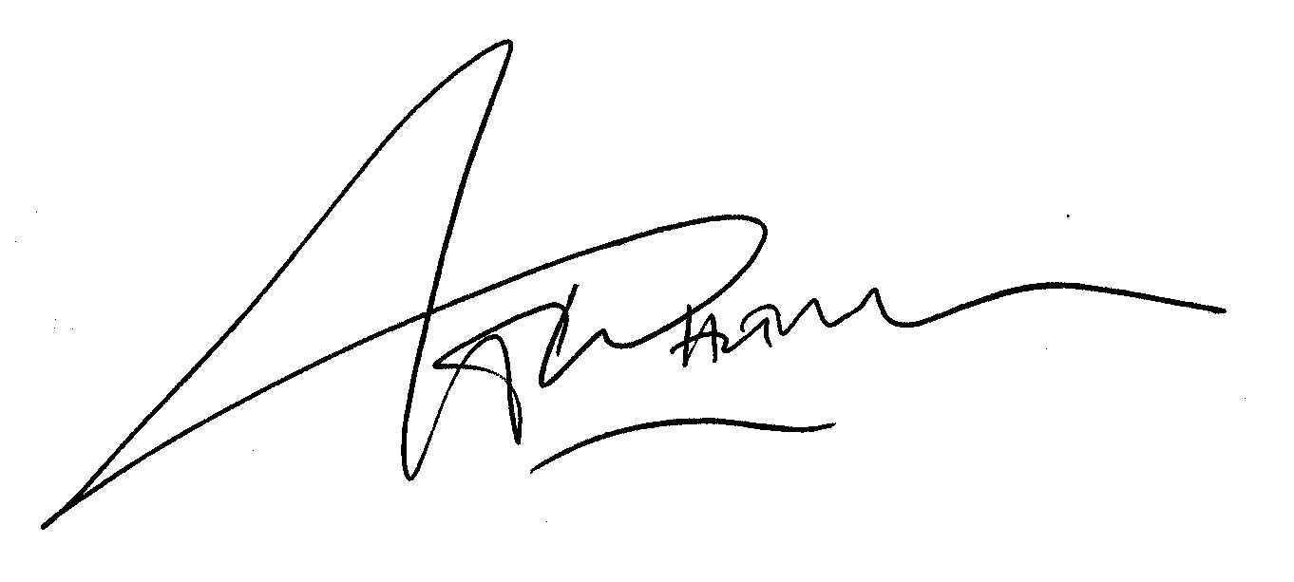

Andrew Whitaker
HBF Head of Planning

