Planning Policy Team
Wyre Borough Council
Civic Centre
Breck Road
Poulton-le-Flyde
FY6 7PU

21 November 2006

Dear Sir or Madam

Wyre Submission Draft Statement of Community Involvement Consultation

Thank you for inviting the Home Builders Federation (HBF) to comment on the submission draft SCI.

The HBF submitted comments to the draft SCI in May this year , we would like to take this opportunity to reiterate previous comments in relation to the outstanding issues. For reference I have attached a copy of a letter dated 25 May 2006 that sets out these comments.

Thank you again for giving the HBF the opportunity to comment. We trust you will take our comments on board and look forward to receiving further information regarding the progress of the document.

Yours sincerely

Gina Bourne
Regional Planner – Northern Region
Home Builders Federation

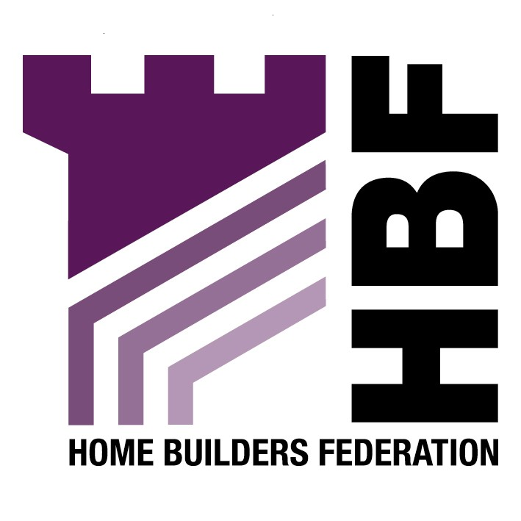

Emailed to planning@wyrebc.gov.uk

Planning Policy Team
Wyre Borough Council
Civic Centre
Breck Road
Poulton-le-Flyde
FY6 7PU

25 May 2006

Dear Sir/Madam

Wyre Borough Council Consultation on the Statement of Community Involvement

Thank you for inviting the Home Builders Federation (HBF) to comment on the submission draft SCI. Please note the following comments.

We welcome the inclusion of The House Builders Federation in Appendix 3 as an organisation to be consulted (Please be advised that The House Builders Federation is now trading as Home Builders Federation).

The reference to developers and landowners being involved in the planning process is welcomed. We would recommend this group are also included in the list of consultees in Appendix 3.

We consider the requirements in paragraph 8.6 are far too onerous and inflexible to the applicant and would not allow the applicant to tailor and personalise their own method of community involvement and consultation. Rather than prescribing methods of consultation, we believe it would be more appropriate for the SCI to provide guidance and advice that an applicant can consider undertaking, but which allows flexibility, and allows the applicant to ultimately chose the method of consultation that would suit them best.

We believe that the expectation that applications for major developments and other developments of community significance will undertake pre-submission community involvement is too onerous, and we consider this could be more flexible, recognising that some proposals, which fall within the category of ‘major development’ would not necessarily need to undertake extensive consultation exercises

We feel it is important that the applicant has the flexibility to chose what sort of consultation exercise to undertake, that is best suited to reflect the scale and nature of the proposal.

We welcome the Council’s comments in paragraph 8.7 that the Council will not refuse to accept valid applications because of the lack of community involvement. However, it must be remembered that just because objections are received (may be or may be not as a result of a lack of community consultation), is not a reason to seek the withdrawal of an application. Community views are not necessarily determinative in planning matters, and objections are not necessarily substantive or material. Each individual application needs to be dealt with on its own merits, and objections taken into consideration only if they are material. Sheer volume of objections does not warrant the withdrawal or refusal of an application.

We are concerned with how the Council imply that an applicant may be asked to withdraw an application or the application will be refused for containing insufficient details to be capable of being properly considered within the target timescales.

HBF would like to emphasise the importance of traditional consultation techniques, namely formal letter and email notification of the availability of documents and the holding of events. Making documents available on the council’s website, for example, is only of benefit if stakeholders are in the practice of regularly checking the council’s website on the off-chance that something new has been announced. It is highly unlikely that most stakeholders will be in a position to do this. However, using emails or standard letters to inform stakeholders that documents are available or events are to be held is a vitally important aspect of the overall consultation and participation process.

It is also welcomed that the resource implications have been considered and acknowledged in section 10 of the SCI.

Thank you again for giving the HBF the opportunity to comment. We trust you will take our comments on board and look forward to receiving further information regarding the progress of the document.

Yours sincerely

Gina Bourne

Regional Planner – Northern Region
Home Builders Federation

