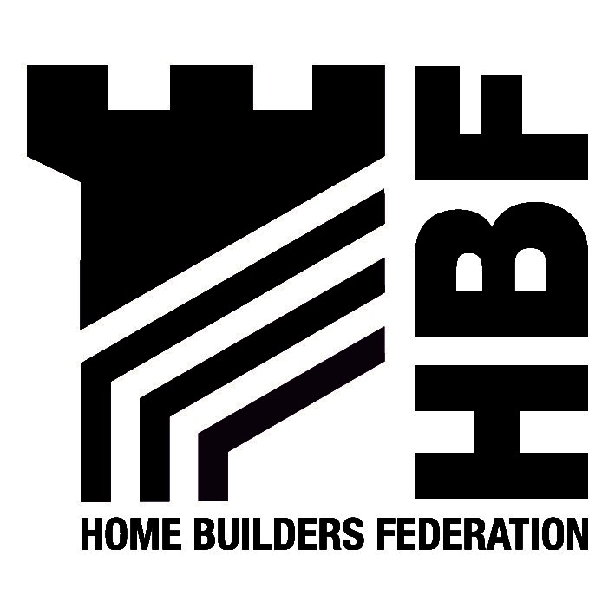

Mark Andrews
Built Environment Services
Harborough District Council
Adam and Eve Street
Market Harborough
Leicester
LE16 7AG

16 October 2006

Dear Mr Andrews

Housing Land Availability Information Paper 2005/06

Thank you for consulting the Home Builders Federation (HBF) on the above Information paper. Please find the HBF’s response below.

The HBF is concerned with regard to the potential under provision of homes for the planned period within Harborough. The housing provision identified within the Information Paper projects a total of 8333 dwellings in the period 2001-2021. This equates to an annual average build rate of 417 dwellings per year.

The Information Paper does not take into consideration the most recent Sub Regional Household Projections (ODPM, Released on 14th March 2006). The projections identify that over the period of 2001-2021 there will be 10,000 additional households, 1667 more than what is projected within the Information Paper. This would equate to an annual average of 500 dwellings constructed per year, which is 83 more than currently projected.

The Federation is concerned that, if the figure is not increased to take account of the above evidence, it could result in a serious under provision of dwellings within the district. Potential detrimental consequences of this include:
- affordability may worsen;
- housing need may not be met locally; and
- market towns and rural communities may suffer as a result.

I hope you find these comments useful. I look forward to receiving notification of the further progress of the LDF.

Yours sincerely

Hanna Mawson
Regional Planner

Midlands and South West

As from 31 May the Midlands HBF Office address and contact details will be as follows:
First Floor, Oakfield House, Small Heath Business Park, Talbot Way, Birmingham, B10 0HJ
T: 0121 260 1554/1555 M: 07730 051968 E: midlands@hbf.co.uk

