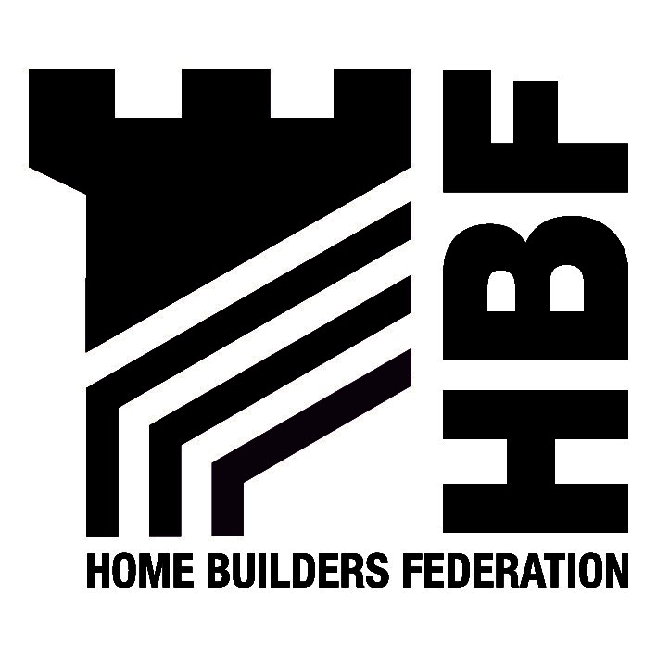

Bridgnorth District Council
Westgate
Bridgenorth
Shropshire
WV16 5AA
31 July 2026

Dear Sirs

Submission Draft Statement of Community Involvement (SCI)

Thank you for the opportunity to comment on Bridgnorth District Council’s Submission Draft Statement of Community Involvement. Please find below the Home Builders Federation’s comments with regard to the SCI.

The Federation is pleased to note its inclusion within the list of consultees at Appendix 4.6 of the SCI and asks that it continue to be consulted at all stages of the LDF process.

With regard to pre-application consultation with the local community, the Federation would like to again raise that this has to remain optional and not compulsory. There can be many reasons why an applicant does not wish to enter into a consultation process prior to the submission of an application and this should remain the applicant’s decision, without unreasonable penalty. In additional, applicants must be allowed to decide the most appropriate means of community involvement and not be required to follow a prescribed method.

We look forward to receiving notification of the further progress of the LDF.

Yours faithfully

Hanna Mawson
Regional Planner

Midlands and South West

Please note the change of name to the Home Builders Federation
As from 31 May the Midlands HBF Office address and contact details will be as follows:
First Floor, Oakfield House, Small Heath Business Park, Talbot Way, Birmingham, B10 0HJ
T: 0121 260 1554/1555 M: 07730 051968 E: midlands@hbf.co.uk

