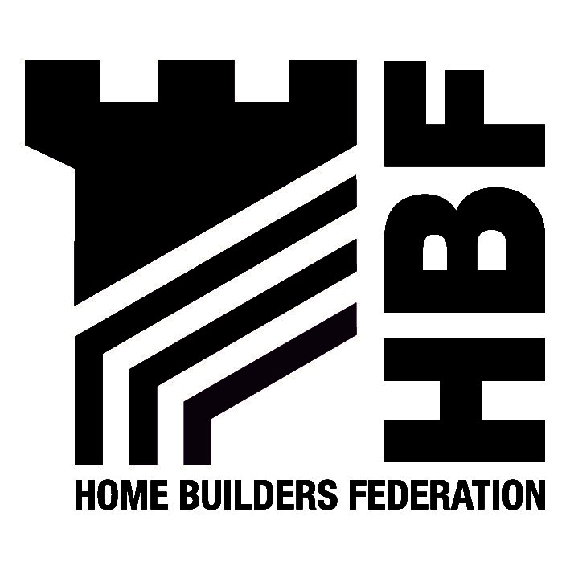

Policy and Development
Development and Regulatory Services
Erewash Borough Council
Town Hall
Long Eaton
Derbyshire
NG10 1HU
30 July 2026

Dear Sirs

Submission Draft Statement of Community Involvement (SCI)

Thank you for the opportunity to comment on Erewash District Council’s Submission Draft Statement of Community Involvement. Please find below the Home Builders Federation’s comments with regard to the SCI.

The HBF would request that matters which relate to developer costs such as affordable housing and developer contributions should be dealt with by DPDs not SPDs. The SCI should identify the precise nature of SPDs to be produced as part of the LDF process.

I would be grateful if you would ensure that the Home Builders Federation is added to the LDF database and that the Federation is given the opportunity to comment on the LDF as it progresses.

Although the advantages of pre-application consultation with the local community is recognised in some instances, it must also be recognised that in some situations it will be inappropriate. For example where developers legal obligations and confidentially preclude this. Such consultation is optional and the lack of pre-application community involvement should not be seen as a determining factor in a planning application. In additional, applicants must be allowed to decide the most appropriate means of community involvement and not be required to follow a prescribed method.

It is considered that the requirement to submit a statement setting out the steps undertaken at the pre-application stage is onerous and unnecessary.

The Federation also asks that the Council includes notification of changes to the LDF and publication of such details on the website, either by letter or e-mail. Over reliance on participatory methods of communication should be avoided and the option always remain open for comment by all parties without attendance at focus groups etc.

We look forward to receiving notification of the further progress of the LDF.

Yours faithfully

Hanna Mawson
Regional Planner

Midlands and South West

Please note the change of name to the Home Builders Federation

As from 31 May the Midlands HBF Office address and contact details will be as follows:
First Floor, Oakfield House, Small Heath Business Park, Talbot Way, Birmingham, B10 0HJ
T: 0121 260 1554/1555 M: 07730 051968 E: midlands@hbf.co.uk

