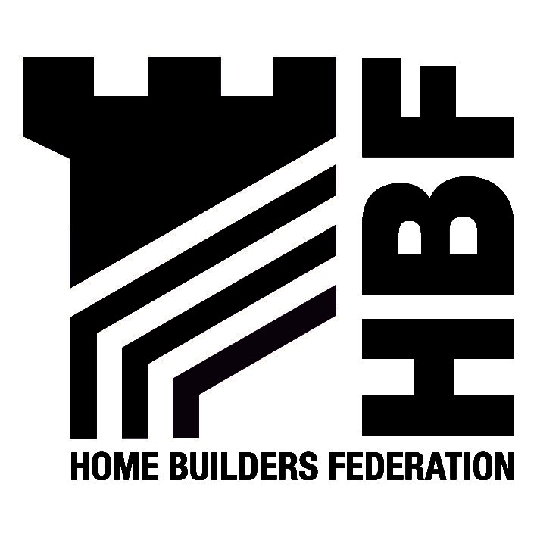

Jake Berriman
Head of Planning and Building Control
South Shropshire District Council
Stone House
Corve Street
Ludlow
SY8 1DG
28 July 2026

Dear Sirs

Draft Statement of Community Involvement (SCI)

Thank you for the opportunity to comment on South Shropshire District Council’s Draft Statement of Community Involvement. Please find below the Home Builders Federation’s comments with regard to the SCI.

The Federation is pleased to note its inclusion within the list of Consultees appended to the document and looks forward to receiving notification of the progress of the LDF.

Although the advantages of pre-application consultation with the local community is recognised in some instances, it must also be recognised that in some situations it will be inappropriate. For example where developers legal obligations and confidentially preclude this. Such consultation is optional and the lack of pre-application community involvement should not be seen as a determining factor in a planning application. In additional, applicants must be allowed to decide the most appropriate means of community involvement and not be required to follow a prescribed method.

The Federation also asks that the Council includes notification of changes to the LDF and publication of such details on the website, either by letter or e-mail. Over reliance on participatory methods of communication should be avoided and the option always remain open for comment by all parties without attendance at focus groups etc.

We look forward to receiving notification of the further progress of the LDF.

Yours faithfully

Hanna Mawson
Regional Planner

Midlands and South West

Please note the change of name to the Home Builders Federation

As from 31 May the Midlands HBF Office address and contact details will be as follows:
First Floor, Oakfield House, Small Heath Business Park, Talbot Way, Birmingham, B10 0HJ
T: 0121 260 1554/1555 M: 07730 051968 E: midlands@hbf.co.uk

