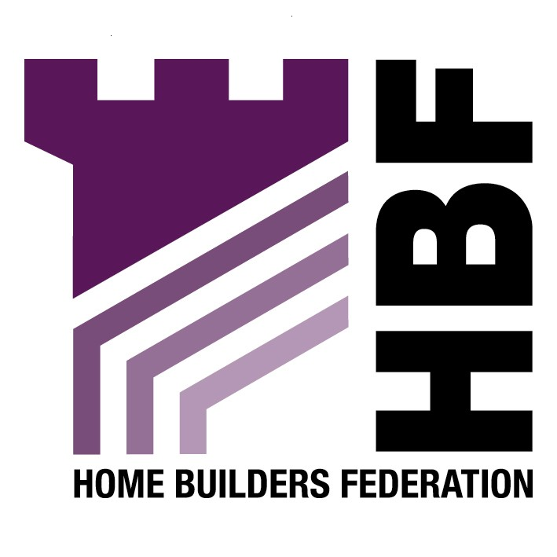

Sheffield Development Framework

Housing Preferred Options for the Core Strategy

Title & First Name | Miss Gina
Surname | Bourne
Organisation | Home Builders Federation
Address | Brooklands Court  Tunstall Road  Leeds
Postcode | LS11 5HL
Telephone | 0113 272 7573
Email | gina.bourne@hbf.co.uk

General Comments

It is noted that for each preferred option the options that have been rejected are listed. However, there appears to be no justification for this rejection, is this available elsewhere? Or will this information be provided at a later date, for example for Examination?

Housing Introduction (paragraph 6.70)

It is noted that paragraph 6.70 refers to the housing requirements for Sheffield as set out in the emerging RSS. The HBF has objected to the overall numbers of housing provision in the RSS as too low and with specific reference to Sheffield, it is considered the numbers are too low for such an influential City Region.

Preferred Option PH1 Locations for new housing development and maintaining a supply of new housing land

HBF supports the approach taken to give priority for the location of new housing land to brownfield land first. However, in line with draft PPS3 it is important to acknowledge that priority should be given to developable brownfield land.

Whilst paragraph 6.72 states Sheffield UPS (2005) indicates that ‘it should be possible to provide enough land on such sites to meet Sheffield’s housing needs’, the HBF considers it is important to ensure that this option is based on a robust up to date Housing Market Assessment.

HBF support the principle of utilizing vacant or underused industrial or commercial land, but would caution against the loss of suitable employment land that could still contribute to employment land needs. HBF suggest such provisions could be added.

Whilst it is noted that specific Greenfield sites at Owlthorpe are considered suitable for new housing land as part of this option, HBF are concerned that restricting Greenfield development to one area will not allow for flexibility in the housing provision of Sheffield. There might be Greenfield sites that are in more sustainable, suitable locations than brownfield sites.

We support the principle of higher densities in the city centre, in and around district centre and along Supertram and core bus network routes, but there needs to be flexibility in this, with a need for lower density family housing. A mix of dwellings is required in order to achieve mixed and balanced communities. A blanket high- density approach in urban areas could lead to an oversupply of apartments. An understanding of the housing market and housing needs of the city is required, which will be provided in a Housing Market Assessment.

Preferred Option PH2 Maximising the use of previously developed land for new housing

Support the statement in paragraph 6.76 that ‘although national and regional guidance means that local authorities should maximize the use of previously developed land, some Greenfield development can sometimes be justified on sustainability grounds’. However, the HBF do not think this guidance has been fully interpreted into preferred option PH2. This preferred option is too inflexible and will not offer any housing choice. A Greenfield site could offer a sustainable development option and Greenfield sites should not be restricted to certain areas.

The restriction of developing Greenfield sites with no open space value will result in the retention of poor quality open space that will detract from the quality of the townscape. It is preferable to put such land to some beneficial use and ensure an efficient use of land.

Preferred Option PH3 Priorities for releasing land for new housing

Whilst we recognise and welcome the need for priority to be given to ensuing the delivery of housing in the Housing Market Renewal area and other priority areas, overall a balanced approach is needed that reflects market demand and delivers housing throughout the city. It is important to delver housing within both low and high demand areas, meeting a variety of housing needs.

In addition, allowing the market to determine the release of previously developed sites for new housing is more likely to ensure that completion rates meet the RSS requirement.

Preferred Option PH4 Efficient use of housing land and accessibility

Please refer to our comments set out in the last paragraph relating to preferred option PH1.

Preferred Option PH5 Affordable Housing

The house building industry is not against the provision of affordable housing. That said we strive to ensure that affordable housing policy is reasonable and achievable alongside the myriad of other developer contributions in order that ultimately affordable housing can be delivered successfully in areas where there is evidence of need.

The provision of affordable housing from developers of private market housing should be based on a robust evidence base of the need for affordable housing. In addition there is a need to ensure that a mix of housing types are delivered throughout Sheffield to meet different housing requirements. The delivery of a mix of private housing, which includes housing that is affordable, can be just as effective if not more successful than prescriptive targets to deliver affordable housing. We would oppose the use of blanket targets that do not reflect the differing affordable housing needs within Sheffield and would prefer a range of targets for different areas based on evidence of need.

