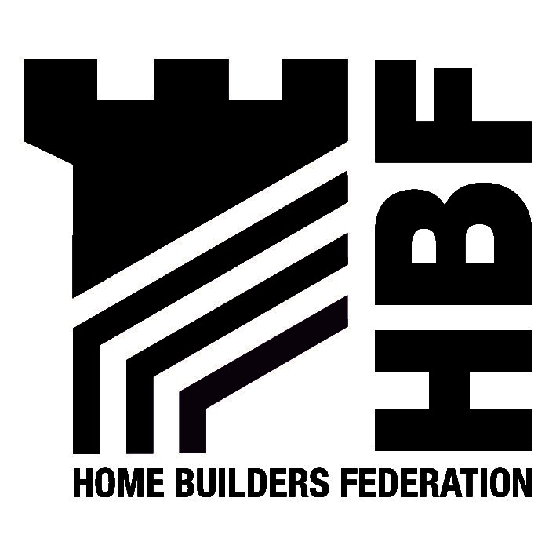

5 October 2005

Dear Sir/ Madam e-mailed to nersspanelsecretary@yahoo.com

HBF response to the draft NE RSS: VIEW

Attached for your consideration are the following two documents:-

- HBF response to VIEW, and
- Appendix 1 including figures HBF1, HBF2 and HBF3.

Whilst overall the Home Builders Federation (HBF) is generally supportive of the VIEW document, we do object to the wording and numbers contained within a number of policies relating to housing provision. On that basis, we respectfully request an invite to the Round Table sessions on housing and related issues such as development options, and delivering economic development and growth.

We also take this opportunity to express concern over the manner in which the VIEW document relates to a number of Technical Background papers. By cross-referencing in this manner, responses to VIEW are almost automatically written in an awkward and jumpy manner. Hopefully, the Examination in Public (EiP) will be structured in a manner that allows topic areas to be considered in single sessions without the excessive need for cross-referencing over a more protracted period.

Finally, we are aware of the following recently commissioned research papers:

- ‘Strategy Integration – Housing, commuting and economic futures – alignment of regional evidence base’, OneNE September – December 2005.
- ‘Locating Homes in the Right Places’, Northern Way Sustainable Communities Workstream, September – December 2005

The conclusions and recommendations likely to be made in both of these research papers will play a part in the RSS EiP along with any proposed amendments suggested in the forthcoming revision to PPG3. In our opinion, communicating these emerging documents as they appear will be a vital role for the Panel Secretary in early 2006.

Should your require any further explanation on the attached submission, please do not hesitate to contact this office.

Regards

Mark Johnson
Regional Policy Manager
Northern Regions (NE, NW, Y&H)

