North Somerset Council Town Hall, Walliscote Grove Road,

Weston-super-Mare, BS23 1UJ.

SENT BY EMAIL

planning.policy@n-somerset.gov.uk

21/03/25

Dear Planning Policy Team,

### NORTH SOMERSET Additional Sites Consultation March 2025

1. Thank you for consulting with the Home Builders Federation (HBF) on the North Somerset Additional Sites Consultation, March 2025 .
2. The HBF is the principal representative body of the house-building industry in England and Wales. Our representations reflect the views of our membership, which includes multi-national PLC’s, regional developers and small, local builders. In any one year, our members account for over 80% of all new “for sale” market housing built in England and Wales as well as a large proportion of newly built affordable housing.
3. The HBF note that this consultation is notionally about additional sites, and the Council is discouraging comments on any other matter. HBF do not comment on individual sites but we have felt it necessary to respond to this consultation because the amount of new sites needed will be dependent on the amount of housing being planned for. We therefore have needed to provide a response to this consultation on behalf of our members.

**Impact of the Dec 2024 revisions to the NPPF**

1. The HBF notes a new NPPF including the new standard method for calculating housing need was published alongside the NPPF on 12th Dec 2024. In our view this has implications for the production of the Plan and the policies it contains. The transitional arrangements set out in the NPPF[1] state that *‘for the purpose of preparing local plans, the policies in this version of the Framework will apply from 12 March 2025 other than where one or more of the following apply: the plan has reached Regulation 19 (pre-submission stage) on or before 12 March 2025 and its draft housing requirement meets at least 80% of local housing need; [or] the plan has been submitted for examination under Regulation 22 on or before 12 March 2025; [or] the plan includes policies to deliver the level of housing and other development set out in a preceding local plan adopted since 12 March 2020 . . .’*.
2. The Government’s is clear that its overarching housing policy seeks to deliver 1.5 million new homes over the course of the Parliament and the introduction of the new stock-based standard method is intended to result in a significant uptick in the delivery of new homes. For new housing to be delivered within the Parliament, work to support this increase must start immediately.
3. In the Bristol City region there is a long-standing and unresolved issue around unmet housing need within the City. Even with the new standard method there is a historic backlog of unmet need, and a need for more housing to support the growth of a region.
4. It is the HBF’s understanding that the intention of the 80% allowance in the standard method was for it to be a test to be applied to Plans that were an advanced stage of preparation and were progressing and had already set a housing number. If, for these Plans, the housing figures were less than 80% of the new standard method the Council needed to revisit the housing figures but if was 80% or more, then the benefits of continuing with a plan and getting a plan in place, albeit with lower numbers, outweighed the disbenefits of not having a Plan.
5. The Government Response to the proposed reforms to the NPPF and other changes to the Planning system consultation[2] provides a helpful flow diagram of the transitional arrangements, which is copied below (see Figure 1). This clearly sets out that Plans at Reg 19 stage should be meeting at least 80% of the standard method. Other national policy in the NPPF, PPG and elsewhere is clear that the Government seeks to increase house building, and Plans that are only aiming to deliver 80% of their part of the national requirement cannot be consistent with the wider Government housing policy objectives. However, in HBF view this does not constrain Council’s to only meeting the standard method.
6. The standard method housing requirement has always been the minimum starting point for setting the housing requirement, and HBF support more housing than the standard method housing requirement in order to support economic growth, provide a range and type of sites and to support small and medium house builders. There is a need to provide a range and choice of sites, a need for flexibility and viability considerations to be taken into account and a need for the Council to consider whether higher levels of open-market housing are required in order to secure the delivery of affordable housing and/or support economic growth.
7. It should also be noted that the flow diagram also clearly sets out a timeframe for the progression of a Plan under the transitional arrangements. The new NPPF therefore provides an important context on the wider Government’s objectives around housing, which add further weight to the concerns we have raised about the failure of this consultation to be planning for enough homes, and therefore not enough sites will be considered.
8. We would suggest that the new requirements and the transitional arrangements underscore that changes are needed to this Plan in relation to housing requirements and its monitoring.
9. We would ask that the Council fully consider the implications of the new NPPF, the intention of the transitional arrangements, and new standard method on this Plan. In HBF’s view, the content of the new NPPF further underlines the importance of the Council taking efforts now to positively plan for the level of housing and infrastructure needed in North Somerset now and not delay these decisions to sometime in the future. We would suggest this includes recognising the challenges the City faces in meeting housing the needs of Bristol in full within its boundary.
10. The Government’s intentions to meet the housing needs of the nation in full, is very clear, and this is reflected in the transitional arrangements. With the Bristol Local Plan at Examination currently, and the likelihood of their still being an unmet need remaining, we would therefore support the Council if they were to choose to take a pause to revisit their approach and then update this plan to reflect both the new housing requirement in full and these wider ambitions for the Region, including supporting growth and delivering more affordable housing .
11. Both the new (2024), and previous (2023) planning guidance are clear that Local Plans should be proactively planning for their area, which includes helping to address the housing crisis. However, the North Somerset Plan is not contributing as much as it could, or should, be to helping to meet this key national housing policy goal. As such the Plan is not doing what it should be to make its contribution to achieving this national policy objective.
12. **Figure One: Transitional Arrangements Flow Diagram**

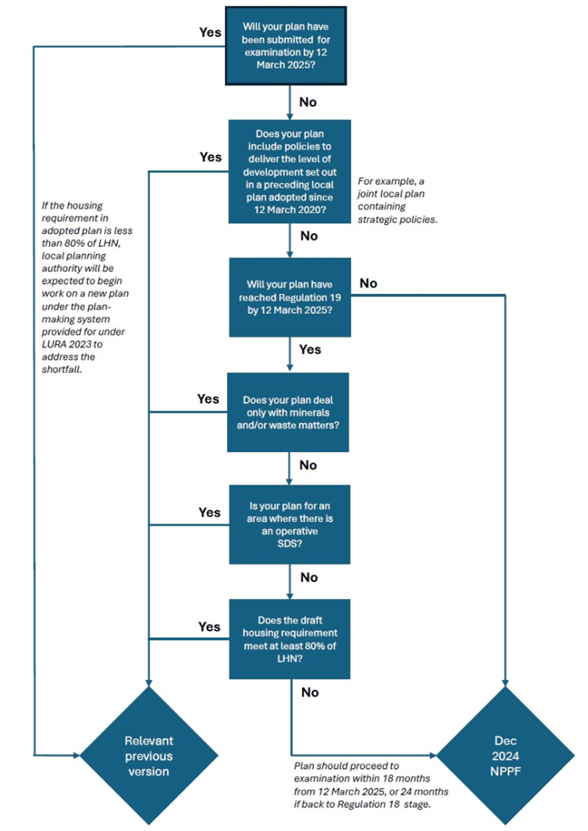

**New Information on BNG and LNRSs**

1. As you may be aware the Government recently[3] published additional Guidance on how Local Nature Recovery Strategies should be integrated with/feed into Local Plan Making[4]. This guidance adds further weight to the comments we are making in relation to the Council taking the time it needs to review its Plan an ensure the full suite of policies being proposed fully reflect this new BNG guidance and fully consider its implications for this Plan.

**The Spatial Strategy**

1. HBF does not comment on individual sites, other than to say the Plan should provide for a wide range of deliverable and developable sites across the area in order to provide competition and choice to ensure that all housing needs are met in full. The soundness of strategic and non-strategic site allocations, whether brownfield or greenfield, will be tested in due course at the Local Plan Examination.
2. Although we do not comment on individual sites, we would however expect the spatial strategy to follow a logical hierarchy that provides an appropriate development pattern and supports sustainable development within all market areas. HBF would request that the Plan’s approach to the distribution of housing should ensure the availability of a sufficient supply of deliverable and developable land to deliver the housing requirement in full.
3. HBF also notes that new settlements and large urban extensions can have long lead times. Reliance on one (or more) new settlement(s) and/or urban extension(s) for housing delivery may mean delivery from these sources will occur later on in the Plan period. This increases the importance of the need for a range of other sites to be provided to ensure a Five-Year Land Supply and early delivery of much needed housing. It will be important for policies and allocation in the Plan to provide for a range of housing sites, and as such the site selection methodology needs to reflect this.

**Housing Requirement**

1. HBF have concerns about the way the Council has arrived at the housing figure that underpins this additional site consultation, as we have previously set out, in the HBF’s view the housing requirement is too low and such additional development, and therefore additional sites, will be needed. This will require the allocation of additional sites in order for the Plan to be sound.

**Future Engagement**

1. I trust that the Council will find these comments useful as it continues to progress its Local Plan. I would be happy to discuss these issues in greater detail or assist in facilitating discussions with the wider house building industry.
2. The HBF would like to be kept informed of all forthcoming consultations upon the Local Plan and associated documents. Please use the contact details provided below for future correspondence.

Yours sincerely,



Rachel Danemann MRTPI CIHCM AssocRICS

Planning Manager – Local Plans (Midlands and South West)

Home Builders Federation

Email: [rachel.danemann@hbf.co.uk](mailto:rachel.danemann@hbf.co.uk)

Phone: 07817865534

1. NPPF 2024 paragraph 234
2. https://www.gov.uk/government/consultations/proposed-reforms-to-the-national-planning-policy-framework-and-other-changes-to-the-planning-system/outcome/government-response-to-the-proposed-reforms-to-the-national-planning-policy-framework-and-other-changes-to-the-planning-system-consultation#the-future-of-planning-policy-and-plan-making
3. On 19th Feb 2025
4. <https://www.gov.uk/guidance/plan-making> and <https://www.gov.uk/guidance/natural-environment#local-nature-recovery-strategies>